
INDUSTRY REPORT
Soft Drink, Baked Goods & Other Grocery Wholesaling in the US
Mar 2026

About

IBISWorld
IBISWorld specializes in industry research with coverage on thousands of global industries. Our comprehensive data and in-depth analysis help businesses of all types gain quick and actionable insights on industries around the world. Busy professionals can spend less time researching and preparing for meetings, and more time focused on making strategic business decisions.

Table Of Contents | Standard

1. About 4
Codes 4
Definition 4
Related Terms 4
What's Included 4
Companies 5
Related Industries 5
Additional Resources 5
2. At a Glance 6
Key Takeaways 6
Products and Services 7
Major Players 8
Key External Drivers 9
Industry Structure 9
SWOT 10
Executive Summary 10
3. Performance 12
Highlights 12
Key Takeaways 12
Performance Snapshot 13
Outlook 22
Life Cycle 25
4. Products and Markets 26
Key Takeaways 26
Products and Services 27
Major Markets 32
International Trade 35
5. Geographic Breakdown 36
Key Takeaways 36
Business Locations 37
6. Competitive Forces 46
Key Takeaways 46
Concentration 46
Barriers to Entry 48
Substitutes 49
Buyer & Supplier Power 51
7. Companies 53
Key Takeaways 53
Market Share 54
Companies 55
8. External Environment 64
Key Takeaways 64
External Drivers 64
Regulation & Policy 67
Assistance 68
9. Financial Benchmarks 69
Key Takeaways 69
Cost Structure 69
Financial Ratios 74
Valuation Multiples 81
Key Ratios 82
10. Key Statistics 84
Industry Data 84

1. About
https://my.ibisworld.com/us/en/industry/42449/about

Codes
NAICS 2017 - USA | 42449
NAICS 2017 - USA | 424490
NAICS 2017 - USA | 424990
NAICS 2022 - USA | 42449
NAICS 2022 - USA | 424490
NAICS 2022 - USA | 424990

Definition
Operators in this industry primarily wholesale specialized grocery products such as soft drinks or baked goods. However, this industry does not wholesale frozen foods, dairy products (except dried or canned), poultry products (except canned), confectionery products, fish and seafood products (except canned), meat products (except canned), alcoholic beverages or fresh fruits and vegetables.

Related Terms

PRIVATE-LABEL
Products sold as the house brand of a particular supermarket or retail chain, rather than the specific manufacturer.

RADIO-FREQUENCY IDENTIFICATION (RFID)
A technology that tracks products from the time they leave the assembly line to the time they leave the store by releasing continuous signals from a chip.

WHOLESALE BYPASS
A popular trend within retail and manufacturing industries in which producers supply goods directly to stores, eliminating the middleman.

What's Included
- Baby foods wholesaling
- Bakery products (except frozen) wholesaling
- Bottled water (except water treating) wholesaling
- Canned foods (e.g. fish, meat, seafood, vegetables, soups) wholesaling
- Cereal products wholesaling
- Coffee and tea wholesaling
- Condiments, seasonings and cooking products wholesaling
- Pasta and rice wholesaling
- Pet foods wholesaling
- Soft drink wholesaling

Companies
- United Natural Foods, Inc.
- Us Foods Holding Corp.
- Sysco Corporation

Related Industries

Industries in the Same Sector
- Competitors:
  - Grocery Wholesaling in the US
  - Packaged Frozen Food Wholesaling in the US
- Complementors:
  - Dairy Wholesaling in the US
  - Egg & Poultry Wholesaling in the US
  - Confectionery Wholesaling in the US
  - Fruit & Vegetable Wholesaling in the US

International Industries
- Soft Drink & Pre-Packaged Food Wholesaling in Australia
- Soft Drink & Pre-Packaged Food Wholesaling in New Zealand
- Juice, Mineral Water & Soft Drink Wholesaling in the UK
- Food, Beverage & Tobacco Wholesaling in Ireland
- Beverage and Tea Wholesalers in China

Additional Resources
- The Food Industry Association
- Associated Wholesale Grocers
- National Grocers Association
- US Census Bureau

2. At a Glance
https://my.ibisworld.com/us/en/industry/42449/at-a-glance
Revenue  $483.1bn  ’21-’26 ↑ 1.1 %  ’26-’31 ↑ 1.3 % | Employees  356k  ’21-’26 ↑ 3.0 %  ’26-’31 ↑ 1.3 % | Businesses  23,814  ’21-’26 ↑ 0.9 %  ’26-’31 ↑ 1.0 %
Profit  $19.3bn  ’21-’26 ↑ 0.6 % | Profit Margin  4.0%  ’21-’26 ↓ 0.1 pp | Wages  $24.3bn  ’21-’26 ↑ 2.0 %  ’26-’31 ↑ 1.3 %

Key Takeaways

Performance
- Health and wellness trends drive product innovation. Wholesalers must adapt to increased demand for healthier options by stocking organic and natural products, partnering with innovative brands and offering transparency to capture a larger market share and enhance customer loyalty.
- Consumer preferences drive market innovation. Demand for healthier, eco-friendly, unique products compels wholesalers to diversify their offerings, adapt to sustainability trends and leverage technology to enhance efficiency and meet evolving needs.

Products and Markets
- Upstream tariffs on Canadian aluminum and Mexican packaging materials will inflate production costs for cans and containers. Higher logistics expenses could force wholesalers to shrink order sizes or pivot to costlier domestic suppliers.
- A 10% baseline tariff on imports will hike costs for soft drinks and baked goods reliant on foreign ingredients like coffee and cocoa. Wholesalers may absorb losses or pass prices to retailers, risking strained relationships as grocery inflation spikes
- Rising consumer health consciousness has reoriented soft drink demand. To meet this shift, wholesalers are increasingly stocking low-calorie, energy-oriented alternatives, aligning their inventories with evolving health preferences.
- Secondary wholesalers are being eliminated from the supply chain. Large retailers are opting to purchase directly from manufacturers, streamlining their operations and reducing costs.

Products and Services
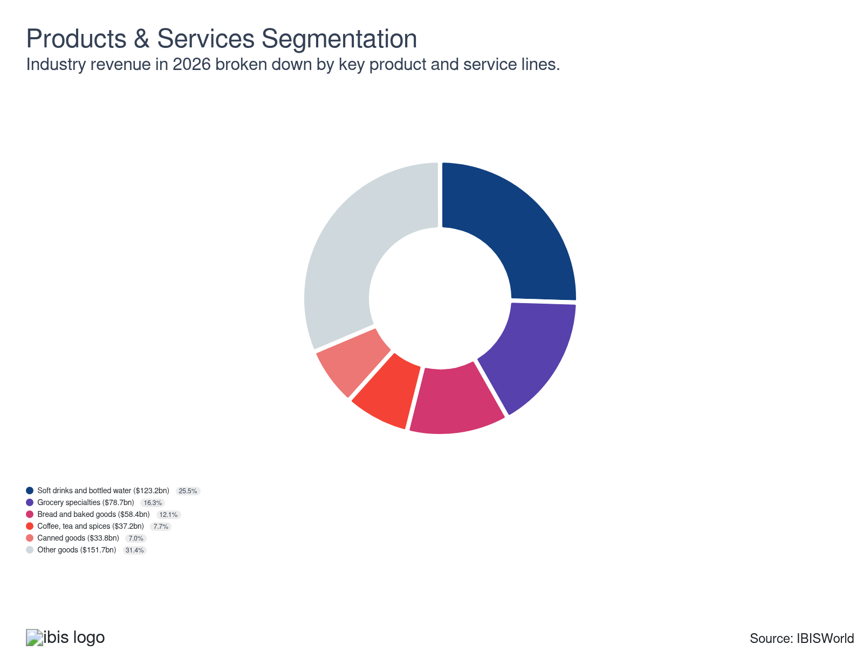

Major Players
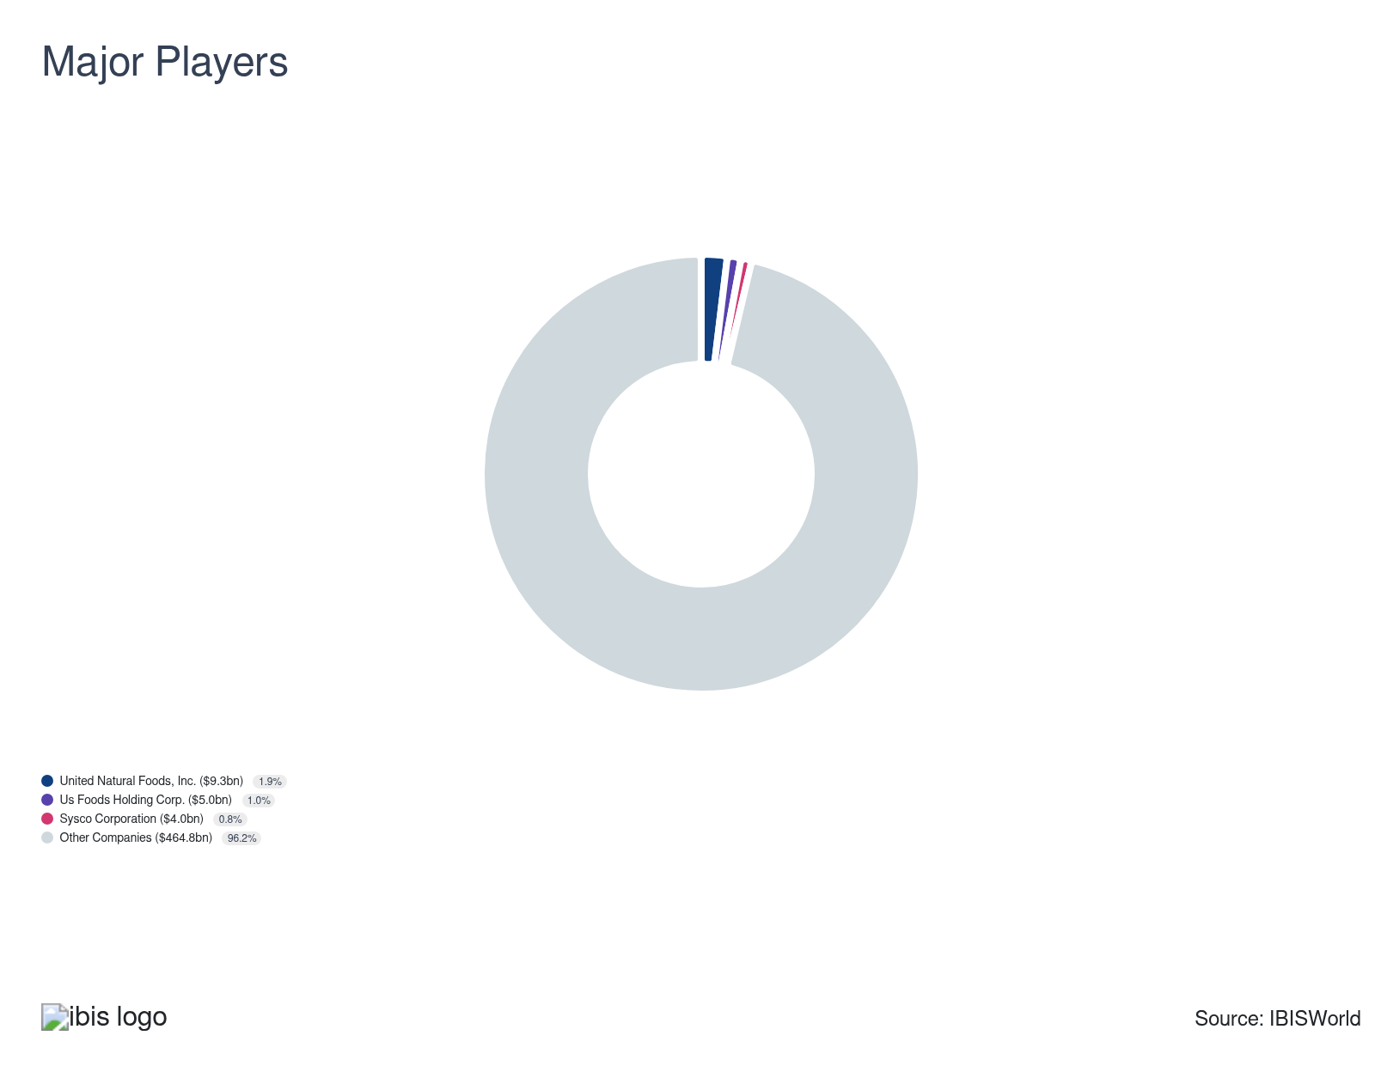

Key External Drivers
Key External Drivers | Impact
Per capita disposable income | Positive
Demand from supermarkets and grocery stores | Positive
Demand from food services and drinking places | Positive
Number of households | Positive
Price of corn | Positive

Industry Structure
Characteristic | Level | Trend
Concentration | Low
Barriers To Entry | Low | Steady
Regulation and Policy | Moderate | Steady
Life Cycle | Mature
Revenue Volatility | Low
Assistance | Low | Steady
Competition | High | Steady
Innovation | Low

SWOT
Strengths  Low Imports  Low Product/Service Concentration | Weaknesses  Low & Steady Barriers to Entry  Low & Steady Level of Assistance  High Competition  Low Profit vs. Sector Average  High Customer Class Concentration  Low Revenue per Employee  High Capital Requirements | Opportunities  High Revenue Growth (2021-2026)  High Revenue Growth (2026-2031)  Demand from food services and drinking places | Threats  Low Revenue Growth (2005-2026)  Low Outlier Growth  Low Performance Drivers  Per capita disposable income

Executive Summary

Hit the shelves: Large upstream manufacturers and downstream retailers will likely continue consolidating
The industry has seen a dynamic shift in recent years. The sector has shown notable resilience amid changing consumer preferences and fluctuating economic conditions. The rising demand for convenience and health-focused products has driven wholesalers to adapt quickly. Innovations like automated warehousing and sustainable packaging have reflected the industry's dedication to efficiency and environmental responsibility. Despite these advancements, increasing input costs and supply chain disruptions have created significant obstacles. Industry-wide revenue has increased at a CAGR of 1.1% over the past five years and is expected to total $483.1 billion in 2026, when revenue will climb by an estimated 1.2% while profit will remain steady at 4.0%.
In the last five years, e-commerce and direct-to-consumer sales have fundamentally changed wholesaler operations, prompting substantial investments in digital infrastructure and logistics. Health and wellness trends have increased demand for organic, non-GMO specialty diet products, pushing wholesalers to expand their product range. Cultural diversity and the popularity of global cuisines have heightened demand for ethnic and international foods. However, traditional staples like canned goods and sugary beverages have experienced fluctuating demand because of shifting consumer preferences and rising health awareness.
Looking ahead, the next five years suggest a transformation in the industry. Technological advancements, particularly in AI and robotics, are anticipated to improve operational efficiency and inventory management. Sustainability will remain a significant focus, with eco-friendly packaging and supply chain practices becoming standard in the industry. Also, the sustained growth of online grocery shopping will push wholesalers to refine their digital strategies and enhance last-mile delivery capabilities. As health-conscious consumers increasingly seek nutritious options, wholesalers must prioritize stocking healthier and specialty products. Overall, the industry is poised for growth, driven by innovation and a continued commitment to meeting consumers' evolving demands. Still, revenue is forecast to grow at a CAGR of 1.3% over the five years through 2031, reaching $516.1 billion.

3. Performance
https://my.ibisworld.com/us/en/industry/42449/performance

Highlights
Revenue  $483.1bn  2021-26 CAGR ↑ 1.1 %  2026-31 CAGR ↑ 1.3 % | Employees  356k  2021-26 CAGR ↑ 3.0 %  2026-31 CAGR ↑ 1.3 % | Businesses  23,814  2021-26 CAGR ↑ 0.9 %  2026-31 CAGR ↑ 1.0 %
Profit  $19.3bn  2021-26 CAGR ↑ 0.6 % | Profit Margin  4.0%  2021-26 CAGR ↓ 0.1 pp

Key Takeaways
- Health and wellness trends drive product innovation. Wholesalers must adapt to increased demand for healthier options by stocking organic and natural products, partnering with innovative brands and offering transparency to capture a larger market share and enhance customer loyalty.
- Consumer preferences drive market innovation. Demand for healthier, eco-friendly, unique products compels wholesalers to diversify their offerings, adapt to sustainability trends and leverage technology to enhance efficiency and meet evolving needs.

Performance Snapshot
Revenue: | ↑ 2021-26 Revenue CAGR +1.1%
Revenue  $483.1bn  ’21-’26 ↑ 1.1 %  ’26-’31 ↑ 1.3 % | 2026 Revenue Growth  ↑ 1.2 % | Revenue Volatility  Low
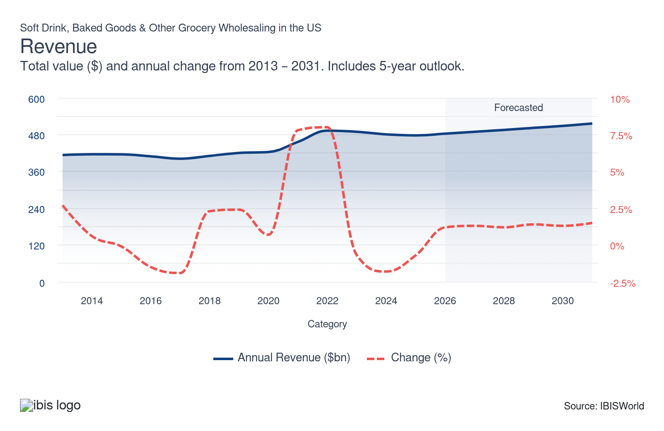
Employees: | ↑ 2021-26 Employees CAGR +3.0%
Employees  356k  ’21-’26 ↑ 3.0 %  ’26-’31 ↑ 1.3 % | Employees per Business  15  ’21-’26 ↑ 2.2 %  ’26-’31 ↑ 0.3 % | Revenue per Employee  $1m  ’21-’26 ↓ 1.8 %  ’26-’31 ↑ 0.0 %
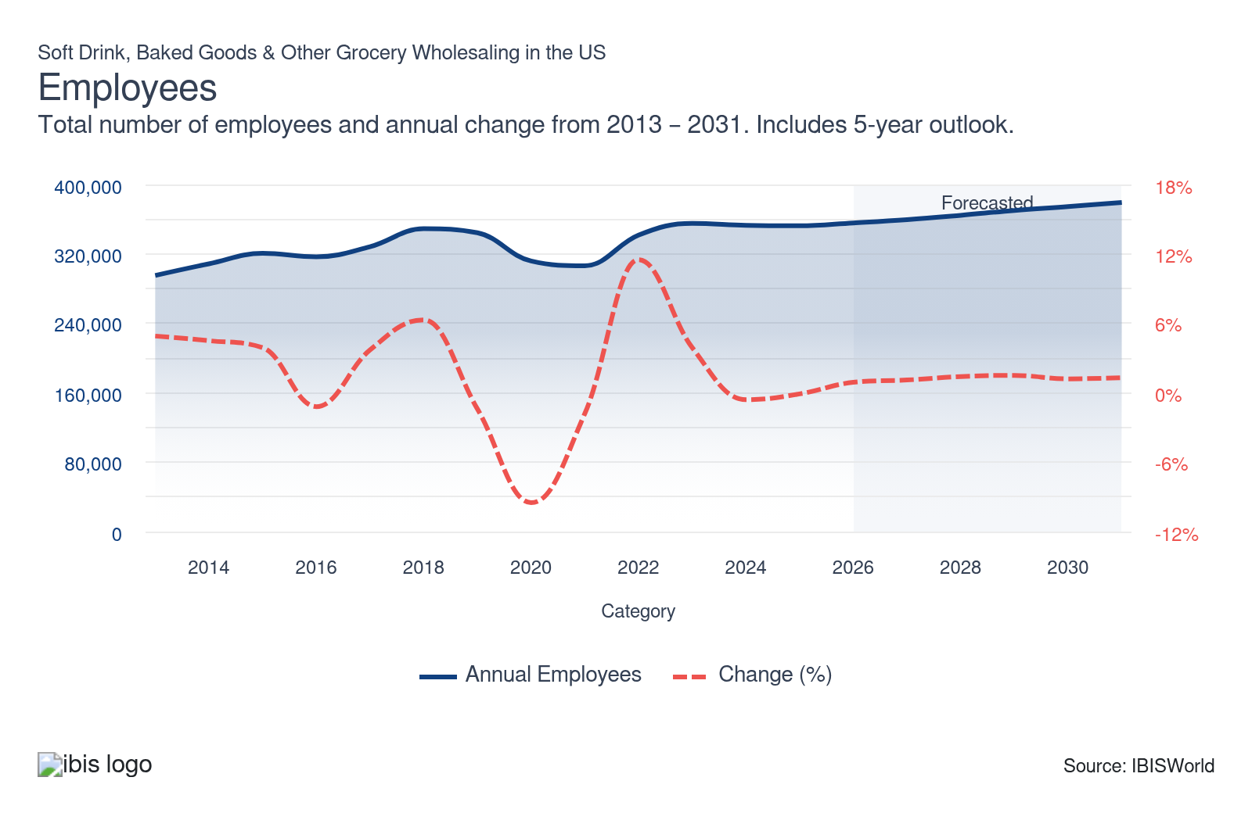
Businesses: | ↑ 2021-26 Business CAGR +0.9%
Businesses  23,814  ’21-’26 ↑ 0.9 %  ’26-’31 ↑ 1.0 % | Employees per Business  15  ’21-’26 ↑ 2.2 %  ’26-’31 ↑ 0.3 % | Revenue per Business  $20.3m  ’21-’26 ↑ 0.3 %  ’26-’31 ↑ 0.3 %
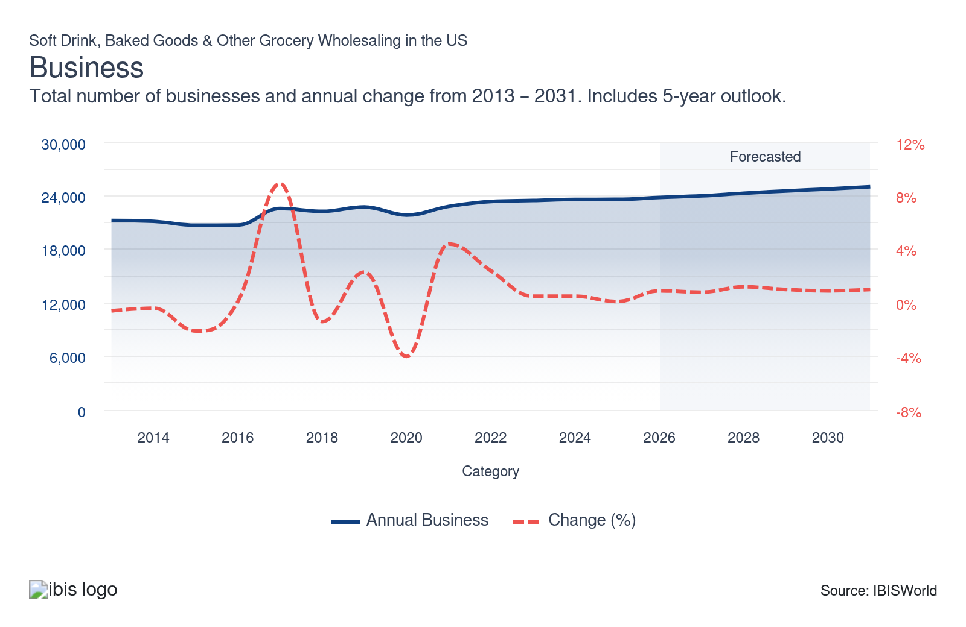
Profit: | ↑ 2021-26 Profit CAGR +0.6%
Total Profit  $19.3bn  ’21-’26 ↑ 0.6 % | Profit Margin  4.0%  ’21-’26 ↓ 0.1 pp | Profit per Business  $811.4k
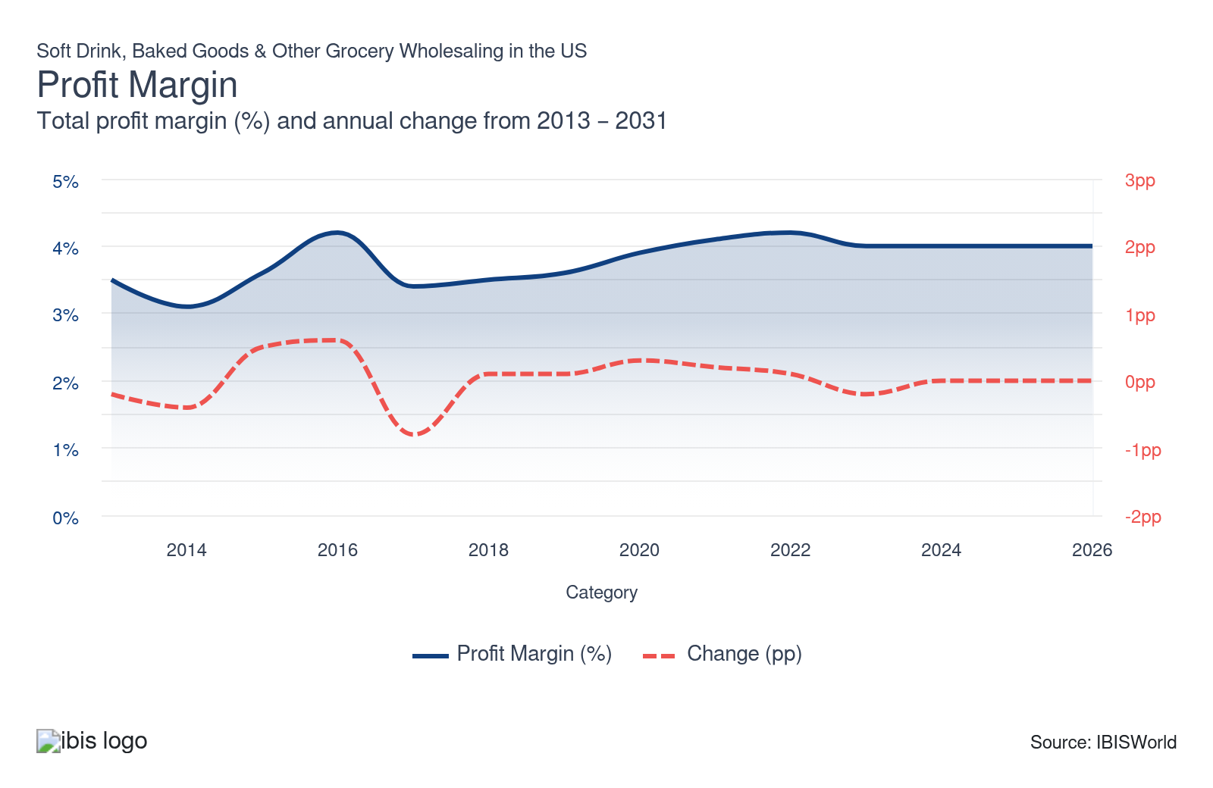
Current Performance
Current Performance

What's driving current industry performance?

The e-commerce boom has been transforming distribution
- As per eMarketer, digital grocery sales in the US are expected to hit approximately $204.6 billion in 2024, increasing by 11.5% annually and accounting for nearly 13% of overall grocery sales, with predictions that digital will emerge as the leading US ecommerce sector by 2026. Key companies such as Walmart and Amazon are now making tens of billions in annual online grocery sales, prompting wholesalers to heavily invest in digital platforms to remain competitive.
- Direct-to-consumer models are evolving, as brands leverage Amazon, Instacart and their own platforms such as PepsiCo’s Snacks.com and PantryShop.com to control data and connections instead of depending only on retail partners. This transition requires enhanced CRM, performance marketing and small-order fulfillment abilities but allows for increased margins, quicker testing of assortments and better control over pricing and brand experience.
- Last-mile innovation is speeding up as retailers and platforms strive to shorten delivery times to 30 minutes or less using drones, autonomous vehicles and extensive gig-economy networks. Walmart has successfully carried out more than 120,000 drone deliveries and is broadening drone services from over 100 locations, with intentions to serve up to 40 million customers via partnerships with Wing and Zipline, elevating the service standards for wholesalers.
- The rise of e-commerce has expanded market access for niche and regional companies, including artisanal brands on Etsy and specialty food vendors on Amazon Marketplace, increasing competition for established wholesalers. To protect market share, wholesalers need to stand out through data-informed selections, enhanced services and analytics that improve pricing and promotions, while nimble rivals utilize marketplaces and social commerce to quickly increase visibility across the country.

Health and wellness trends drive product innovation
- According to the Organic Trade Association, US organic sales reached about $71.6 billion in 2024, up 5.2% year over year, with organic food alone approaching $66 billion and produce accounting for over 30% of all fruit and vegetable sales. This sustained growth pushes wholesalers to deepen partnerships with certified organic farms and scale assortments of organic snacks, dairy and fresh items to capture premium demand.
- In response to consumer demand, many companies are reformulating products to cut sugar, sodium and artificial ingredients. Brands like PepsiCo and General Mills have launched healthier versions of popular items, including low-sugar sodas and whole-grain cereals. Wholesalers must remain informed about these reformulations to ensure they stock the latest offerings. Also, educating consumers on the benefits of these healthier alternatives could increase sales and foster customer loyalty.
- Interest in functional foods and beverages offering added health benefits, such as probiotics, vitamins and minerals, is on the rise. This trend has spurred the popularity of kombucha, fortified waters and protein-enriched snacks among health-conscious consumers. For wholesalers, partnering with innovative brands and maintaining a steady supply of these products can attract a broader customer base and strengthen market positioning.
- Consumers increasingly seek transparency and cleaner labels, favoring products that emphasize the absence of artificial additives and the inclusion of organic ingredients. This demand pushes wholesalers to offer products with clear and informative labels. By providing detailed product information and promoting transparency, wholesalers can build consumer trust and loyalty, ultimately enhancing sales.

Supply chain disruptions reshape operations
- Supply instability continues to be a concern at the board level, with surveys showing that a majority of European shippers experienced disruptions in 2024 and almost 88% of global companies intend to restructure supply chains in 2025 to enhance resilience, according to Economist Impact. Wholesalers are reconfiguring networks, incorporating redundancy into essential categories, and reevaluating inventory strategies to maintain service levels during ongoing geopolitical, capacity, and tariff disruptions.
- To minimize vulnerability, wholesalers are diversifying their supplier sources across various regions and incorporating nearshoring to Mexico, Canada, and other nearby partners, reducing reliance on any one country. This varied model necessitates enhanced supplier evaluation, continuous performance tracking, and closer collaboration on forecasts, yet it stabilizes supply flows and boosts responsiveness when routes or nodes face constraints.
- Digitalization is essential for resilience as numerous wholesalers implement AI-powered planning, predictive analytics, and real-time monitoring to foresee bottlenecks and manage inventories throughout networks. These instruments assist in predicting demand fluctuations, modeling disruption scenarios, and refining reorder thresholds, enabling companies to achieve better service levels with reduced inventory while responding more swiftly to shipping delays or unexpected increases in volume.
- Local and regional sourcing approaches are becoming more popular, as businesses move certain categories nearer to consumption markets to decrease lead times and minimize logistics risk. This method enhances connections with local producers, reduces transportation emissions, and provides protection against international disruptions, offering wholesalers a resilience benefit and allowing for fresher selections that can be restocked more often and adaptively when global supply routes face challenges.

Sustainability concerns influence business practices
- In response to environmental concerns, wholesalers are increasingly adopting eco-friendly packaging solutions, using recyclable, biodegradable and compostable materials to lower their environmental impact. Coca-Cola, for instance, has launched bottles made from 100.0% recycled plastic in various markets. This shift necessitates a reassessment of supply chains, encouraging partnerships with packaging suppliers that provide sustainable options. Embracing eco-friendly packaging can boost a company’s brand image and attract environmentally conscious consumers.
- Companies are rolling out waste reduction initiatives to tackle food waste, with strategies centering on improved inventory management and food donation programs. Kroger’s Zero Hunger | Zero Waste plan aims to eradicate food waste by 2025. Effective waste reduction yields cost savings, boosts operational efficiency and strengthens corporate social responsibility (CSR) profiles. Wholesalers that successfully minimize waste can attract customers and investors focused on sustainability.
- The emphasis on energy efficiency in warehousing and transportation is intensifying, with wholesalers investing in renewable energy sources like solar panels and energy-efficient technologies such as LED lighting and electric delivery vehicles to cut carbon emissions.
- Amazon, for instance, has pledged to reach net-zero carbon by 2040, heavily investing in renewable energy and electric vehicles. These investments have the potential to substantially lower operational costs and carbon footprints over time. Moreover, adopting energy-efficient practices helps wholesalers comply with stricter environmental regulations and aligns with consumer demand for sustainable business practices.

What influences industry volatility?

Health trends constantly reshape consumer demand in grocery industry
- As health-conscious consumers move away from sugary drinks and processed baked goods, legacy brands face unpredictable dips in demand. This shift challenges traditional staples and reflects a broader trend towards healthier eating habits that disrupt established consumption patterns.
- Niche products, such as low-sugar snacks and gluten-free baked goods, are experiencing a surge in popularity. However, their demand can be fleeting, requiring wholesalers to constantly adapt their inventory to keep pace with evolving consumer preferences and maintain relevance.
- This rapid change in consumer behavior creates revenue unpredictability, particularly for wholesalers heavily invested in traditional product lines. Failure to adapt quickly risks financial instability as these entities grapple with shifting market dynamics and consumer tastes.
- Wholesalers unable to pivot effectively face the potential of holding unsellable stock or missing out on emerging trends that capture retailer interest and shelf space. Agility in response to consumer health trends becomes crucial for sustaining growth and competitiveness.

Retailer consolidation challenges traditional wholesale partnerships
- Major retailers, including Walmart and Kroger, are expanding through acquisitions and bolstering their internal distribution networks, decreasing dependence on traditional wholesalers. This shift alters the landscape and forces wholesalers to reassess their roles and strategies within the supply chain.
- As these retail giants amass greater bargaining power, they often demand lower prices or bypass middlemen, significantly impacting revenue opportunities for smaller and regional wholesalers. This increased pressure challenges the sustainability of traditional wholesale operations.
- Losing a large retail client can result in substantial revenue gaps for wholesalers, particularly those with concentrated customer bases. Replacing such clients is increasingly difficult in a competitive market, underscoring the importance of diversification.
- To maintain stability in this shifting environment, wholesalers must continuously diversify their client portfolios and service offerings. Adapting to the evolving market demands is essential for sustaining revenue and ensuring long-term viability.
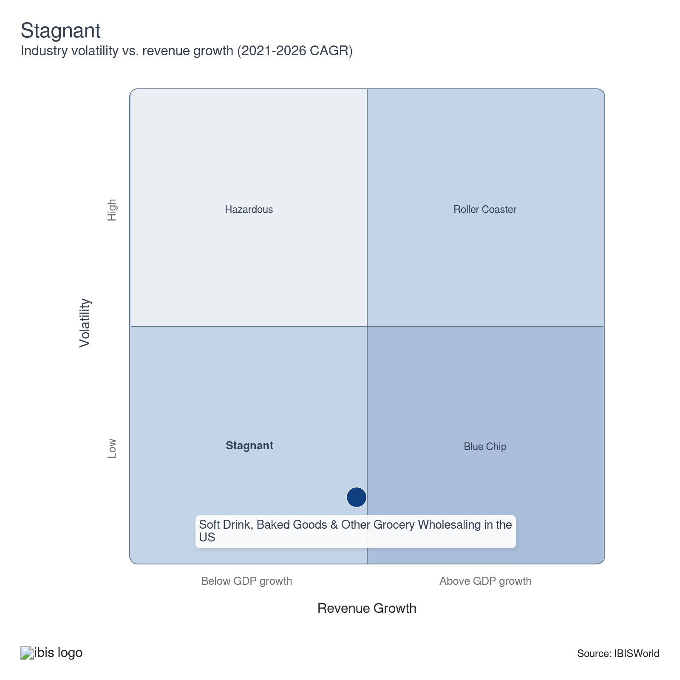

How do successful businesses overcome volatility?
Develop contacts within key markets
To ensure their success, wholesalers must cultivate and maintain strong relationships within retail markets, a crucial element for effective distribution and business transactions.
Vary services to suit different needs
Successful wholesalers offer additional services, such as store planning, inventory control and marketing services, which they adjust to suit the needs of individual customers.
Outlook | ↑ 2026-31 Revenue CAGR +1.3%

What's driving the industry outlook?

Evolving consumer preferences drive product innovation
- Consumers' growing emphasis on health and wellness fuels demand for healthier food and beverage options. Products with reduced sugar content, natural ingredients and functional benefits, such as added vitamins or probiotics, are increasingly sought after. Brands like KIND and RXBAR have tapped into this trend by providing snack bars with minimal ingredients and no added sugars. This shift towards health-conscious products compels wholesalers to broaden their inventory to include these offerings, ensuring they meet the needs of a health-aware consumer base.
- Rising environmental awareness is prompting consumers to prefer sustainably sourced and eco-friendly products. Brands prioritizing sustainable practices in sourcing and packaging are likely to benefit from heightened customer loyalty. According to The Hartman Group, the market share for sustainably produced goods is expected to expand by 20.0% by 2028.
- Consumers are increasingly drawn to bold and unique flavors, showing a growing interest in exploring new and exotic tastes, including international and multicultural options. Nielsen reports that 45.0% of consumers are eager to try new flavors regularly. With their "Do Us a Flavor" campaign featuring limited-edition offerings and Ben & Jerry's inventive ice cream combinations, brands like Lay's illustrate the market's appetite for flavor innovation. Wholesalers can seize this opportunity by stocking diverse innovative and exotic flavor products, appealing to a wider customer base.
- The increasing demand for convenience propels the growth of ready-to-eat and ready-to-drink products. As busy lifestyles become more prevalent, consumers look for quick and easy options that maintain quality and health benefits. Lunchables and Ready Pac Foods cater to this need with convenient meal solutions. Grocery wholesalers need to include a substantial selection of convenience products to meet this growing demand, thereby enhancing their product offerings and appealing to time-strapped customers.

Sustainability initiatives will gain momentum
- The drive for sustainability is expected to result in wholesalers' greater adoption of eco-friendly packaging materials. To align with consumer demands and regulatory requirements, wholesalers increasingly use biodegradable, recyclable and compostable packaging.
- According to Grand View Research, the global market for sustainable packaging is projected to grow at a compound annual growth rate of 7.6% from 2024 to 2030. This trend highlights the importance of integrating sustainable practices within the supply chain to remain competitive and meet evolving expectations.
- Companies are set to implement several key strategies to reduce their carbon footprints. These include optimizing transportation routes to minimize emissions, investing in renewable energy sources and improving energy efficiency within warehouses. Such initiatives help achieve sustainability goals and contribute to cost savings and compliance with environmental regulations while appealing to environmentally conscious consumers.
- A stronger emphasis is emerging on sourcing products from suppliers committed to sustainable farming and production practices. This trend involves prioritizing fair trade, promoting organic farming and ensuring humane animal treatment. By aligning with these ethical and sustainable practices, wholesalers can enhance their brand reputation, meet the growing consumer demand for responsible products and contribute positively to environmental and social outcomes.

Technological advancements reshape supply chains
- Automation and artificial intelligence (AI) are set to revolutionize supply chain operations by enhancing efficiency and reducing costs. Wholesalers are expected to incorporate technologies such as automated warehousing, AI-driven demand forecasting and robotic process automation. These innovations improve operational performance and profitability by optimizing inventory management, reducing waste and adjusting stock levels more accurately.
- Adopting these advanced technologies provides a competitive edge for wholesalers, allowing them to respond swiftly to market changes and consumer needs. This shift better positions businesses to meet higher consumer expectations and adapt to evolving market demands, potentially leading to increased market share and new growth opportunities.
- Integrating Internet of Things (IoT) connectivity within supply chains is poised to transform operations through real-time monitoring and data collection, spanning production to delivery. This enhanced connectivity offers significant benefits, including improved inventory management, reduced waste and heightened operational efficiency. According to Gartner, more than 50.0% of new business systems will leverage IoT for logistics tracking and management by 2025. This advancement streamlines processes and equips businesses to respond swiftly to changing demands, positioning them for more efficient and responsive supply chain management.
- The deployment of advanced analytics will empower wholesalers with deeper insights into consumer behavior and market trends. This data-driven decision-making approach will become essential for optimizing inventory, tailoring marketing strategies and accurately forecasting demand. By leveraging analytics, wholesalers can refine their operations, enhance customer engagement and stay competitive in a rapidly evolving market.

A new wave of digital disruption is reshaping US wholesale distribution
- The direct-to-consumer (DTC) approach is gaining traction as manufacturers and retailers bypass traditional wholesalers to connect directly with customers. Driven by e-commerce expansion and sophisticated digital marketing, this shift allows brands to engage audiences, personalize experiences and enhance profits by eliminating intermediaries. It is also urging wholesalers to innovate for competitiveness.
- Retailers increasingly implement omnichannel strategies to create a seamless shopping experience across online, mobile and in-store platforms. This requires wholesalers to be agile and responsive in managing inventory and logistics, ensuring timely product availability and strengthening supply chain partnerships, ultimately boosting customer satisfaction and loyalty.
- Businesses turn to collaborative logistics and shared warehousing to cut costs and increase efficiency. Multiple companies can optimize space usage and lower expenses by sharing transportation and storage resources. This trend fosters cost-effective operations and sustainability by minimizing redundancies and reducing carbon footprints, creating a cooperative supply chain environment.
- As sustainability becomes paramount, wholesalers are increasingly adopting eco-friendly practices and technologies. This includes investing in energy-efficient systems, reducing packaging waste and exploring renewable energy sources. By prioritizing sustainability, wholesalers meet consumer and regulatory demands and differentiate themselves in the market, paving the way for long-term success.
Life Cycle | Mature

Why is the industry mature?

Contribution to GDP
The industry's growth has surpassed the overall economy, underscoring its vital role. It thrives when consumers have more disposable income on groceries, reflecting its essential contribution to economic health. As purchasing power increases, demand for diverse and high-quality food products drives expansion and innovation within the sector.

Market Saturation
The unique and specialized nature of certain industry products inherently limits the expansion of major wholesalers. Catering to niche markets often restricts large-scale operations, as it demands tailored approaches and careful attention to specific consumer needs, constraining widespread scalability and requiring focused expertise.

Innovation
The industry has little innovation because of the fundamental nature of product distribution. Limited innovation is expected to occur moving forward, leaving the industry to operate similarly as it has over the past decade. Product innovation occurs at the manufacturing level.

Consolidation
While consolidation has occurred in certain product lines, it is limited by the specificity of many industry distributors. This specificity demands tailored distribution strategies and expertise, making it challenging for larger entities to absorb niche companies without losing the personalized touch required to serve these distinct markets effectively.

Technology & Systems
The industry is unlikely to see breakthroughs in the next five years. Technological advancements will primarily focus on optimizing efficiency and reducing costs. These improvements aim to streamline operations and enhance productivity rather than introducing groundbreaking changes to the industry's fundamental structure or offerings.

4. Products and Markets
https://my.ibisworld.com/us/en/industry/42449/products-and-markets
Largest Market  $151.7bn  Other goods | Product Innovation  Low

Key Takeaways
- Upstream tariffs on Canadian aluminum and Mexican packaging materials will inflate production costs for cans and containers. Higher logistics expenses could force wholesalers to shrink order sizes or pivot to costlier domestic suppliers.
- A 10% baseline tariff on imports will hike costs for soft drinks and baked goods reliant on foreign ingredients like coffee and cocoa. Wholesalers may absorb losses or pass prices to retailers, risking strained relationships as grocery inflation spikes
- Rising consumer health consciousness has reoriented soft drink demand. To meet this shift, wholesalers are increasingly stocking low-calorie, energy-oriented alternatives, aligning their inventories with evolving health preferences.
- Secondary wholesalers are being eliminated from the supply chain. Large retailers are opting to purchase directly from manufacturers, streamlining their operations and reducing costs.

Products and Services
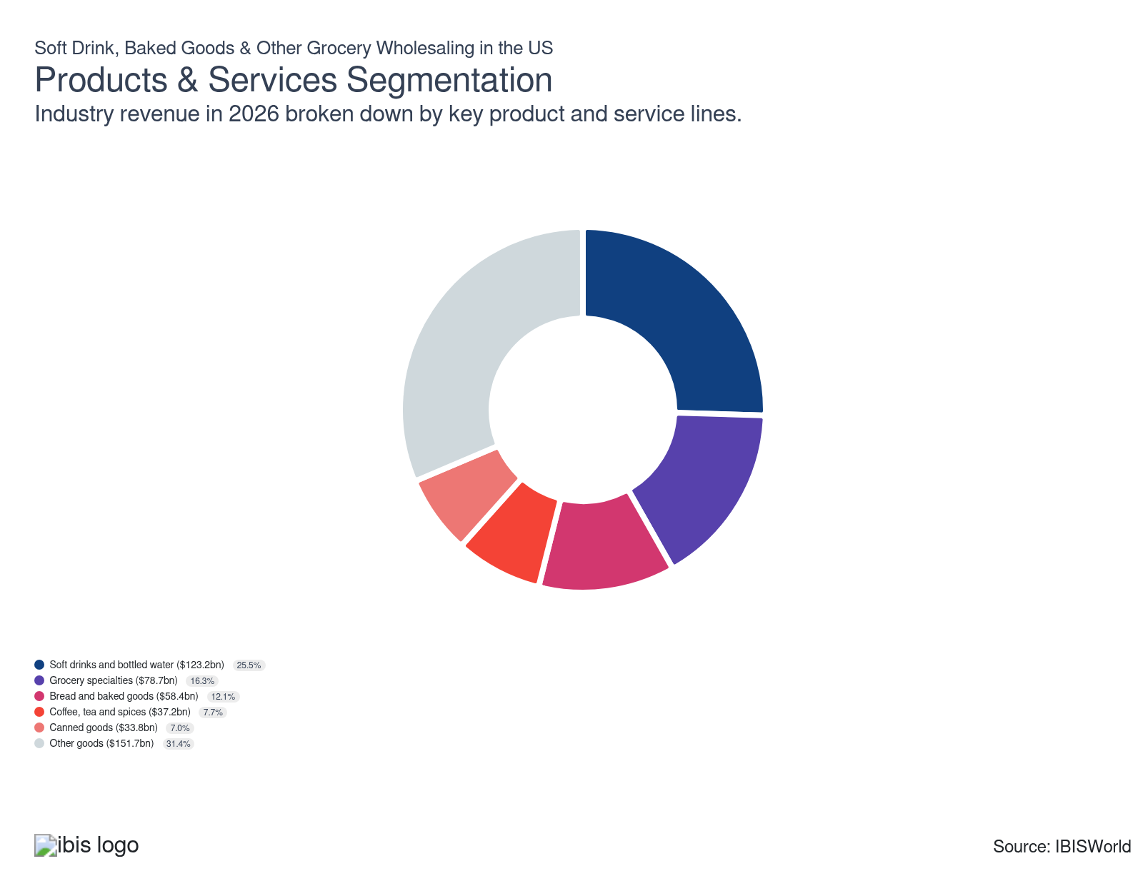

How are the industry’s products and services performing?

Bread and baked goods demand shifts wholesale strategies
- Bread and baked goods cover diverse products like loaves of bread, rolls, pastries, cakes and cookies. As staple foods in numerous households and institutions, these items are crucial for wholesalers to include in their inventory. Their consistent demand underscores their importance in maintaining a well-rounded product offering.
- Rising consumer awareness of health and wellness drives greater demand for whole grain, gluten-free and low-sugar baked goods. Wholesalers are adapting by sourcing and supplying these healthier options to align with shifting consumer preferences. This change reflects a broader trend in the food industry towards more health-conscious product offerings.
- The increasing demand for artisanal and specialty baked goods, such as sourdough bread and gourmet pastries, is prompting wholesalers to expand their product lines to include high-quality, niche items. This diversification aims to cater to consumers seeking unique and premium options, reflecting a growing interest in distinctive and handmade products in the market.
- Ingredient shortages and transportation delays affect the availability and cost of bread and baked goods. To address these challenges, wholesalers are tasked with optimizing their supply chains and maintaining robust inventories. These efforts are crucial to ensure product availability and mitigate supply disruptions' impact on pricing and distribution.

Coffee, tea, and spices demand brews wholesale changes
- Coffee, tea and spices encompass a wide range of products, including ground coffee, coffee beans, tea leaves, tea bags and various spices and seasonings. These items are integral to both household and commercial culinary applications, establishing them as essential products for wholesalers to stock. Their consistent demand highlights their significance in both everyday and specialized cooking needs.
- Growing consumer interest in the health benefits of coffee, tea and certain spices, such as turmeric and ginger, is fueling demand for organic, sustainably sourced and specialty products. In response, wholesalers are expanding their offerings to include these sought-after items to appeal to health-conscious consumers. This shift reflects an industry-wide trend towards healthier and more ethically sourced options.
- Climate change and geopolitical issues impact coffee, tea and spice production and supply, resulting in price volatility and inconsistencies. Wholesalers must navigate these challenges by diversifying their supply sources and implementing effective inventory management strategies. By doing so, they can better mitigate risks, maintain product availability and stabilize pricing for their customers despite external disruptions.

Soft drinks and bottled water demand refreshes wholesale market
- Soft drinks and bottled water encompass a broad spectrum of beverages, including carbonated sodas, flavored sparkling waters, sports drinks, energy drinks and various types of bottled still water. These products are vital components of the beverage market, offering multiple options to satisfy diverse consumer preferences for hydration and refreshment.
- Growing health awareness drives consumer preferences towards low-sugar, zero-calorie beverages with natural ingredients. In response, wholesalers are adjusting their product mix to include healthier options like flavored waters and diet sodas to cater to this increasing demand. This shift underscores the market's emphasis on health-conscious choices in beverage offerings.
- Increasing environmental awareness encourages consumers to choose brands with sustainable packaging and eco-friendly practices. As a result, wholesalers prioritize sourcing products from manufacturers dedicated to sustainability, influencing supplier relationships and inventory decisions. This trend highlights the growing importance of environmental responsibility in product selection and supply chain management.

Grocery specialties drive wholesale market dynamics
- Grocery specialties include a diverse range of niche and high-value food items, such as organic and gourmet foods, ethnic and international cuisine products, specialty diet options like gluten-free and vegan offerings and artisanal goods. These products appeal to consumers looking for unique, high-quality, or health-conscious choices, reflecting evolving trends and preferences in the food market.
- The rising consumer emphasis on health and wellness is driving increased demand for organic, non-GMO, and specialty diet products. In response, wholesalers are diversifying their offerings to include more of these health-focused items, influencing their sourcing and inventory strategies. This shift reflects the broader market trend towards prioritizing healthier and more sustainable food options.
- Consumers are increasingly drawn to high-quality, premium and artisanal grocery items. To cater to this trend, wholesalers are stocking a diverse range of these specialty products, which typically carry higher price points. This strategy aims to attract discerning customers who seek unique culinary experiences and are willing to invest in distinctive, superior offerings.

Canned goods are essential during economic downturns
- Canned goods comprise a wide range of preserved food products, including vegetables, fruits, meats, soups, beans, and ready-to-eat meals. Renowned for their long shelf life, convenience, and affordability, these items are staples in both households and institutions, providing reliable options for easy meal preparation and storage.
- In periods of economic instability, consumers often stock up on non-perishable items like canned goods because of their cost-effectiveness and extended shelf life. This behavior increases demand for these products, prompting wholesalers to boost inventory levels to adequately meet consumer needs. This trend highlights the role of canned goods as a reliable option during uncertain times.
- The preference for canned goods featuring lower sodium content, organic ingredients and no artificial preservatives is on the rise. Wholesalers are adapting to cater to health-conscious consumers by sourcing healthier canned options. This shift reflects a broader demand for more nutritious and clean-label food products.
- Demand for convenience and preparedness has surged, particularly following recent global events. The ease of storage and preparation offered by canned goods has increased in popularity, prompting wholesalers to maintain a robust supply. This trend underscores the importance of readily accessible and reliable food options in uncertain times.

Other goods find a home
- Other diverse food products include flavoring extracts, brewer's yeast, hops, gelatin, health foods and assorted snacks. These products offer versatility and cater to varying consumer needs across different culinary applications.
- This category also encompasses products classified under other sectors when fresh, such as poultry or dairy, if they are processed. Examples include canned chicken or powdered milk. This approach allows for the inclusion of items that, through preservation methods, serve needs beyond their fresh counterparts.

What are innovations in industry products and services?

Warehouse automation is boosting efficiency
- Robotics and AI are becoming integral to warehouse operations, allowing wholesalers to streamline repetitive tasks like sorting, picking and packing. This adoption enhances efficiency and reduces labor costs, enabling businesses to optimize their resources and improve productivity.
- Advanced AI systems provide real-time inventory tracking, giving wholesalers precise control over stock levels. This capability reduces the risks of overstocking or stockouts, ensuring inventory is managed effectively and replenished promptly to meet demand.
- Automation technologies are transforming warehouse management by improving operational accuracy and speed. These innovations help wholesalers maintain competitive advantages in a fast-paced market, providing more efficient fulfillment and better customer satisfaction.

Sustainable packaging is gaining traction
- Wholesalers are increasingly adopting sustainable packaging solutions, using biodegradable and recyclable materials to align with consumer demand for eco-friendliness. This shift reduces the carbon footprint and attracts environmentally conscious customers, enhancing brand appeal and market competitiveness.
- Innovations like edible packaging for baked goods are being explored. This approach offers a unique way to minimize waste while providing an enhanced consumer experience, serving as a distinctive selling point and setting businesses apart in a crowded marketplace.
- The push towards sustainable packaging reflects a broader industry commitment to environmental responsibility. Wholesalers aim to meet evolving customer expectations and regulatory requirements by prioritizing eco-friendly practices and fostering long-term sustainability.

What products or services do successful businesses offer?
Ability to control stock on hand
Effective inventory management allows wholesalers to minimize storage costs by accurately tracking stock levels, optimizing order quantities and forecasting demand, preventing overstock situations, and ensuring sufficient supply to meet customer needs.
Ability to vary services to suit different needs
Successful wholesalers differentiate themselves by providing value-added services like store planning, tailored inventory management and personalized marketing strategies. They adapt these services to meet each client's unique needs and preferences.

Major Markets
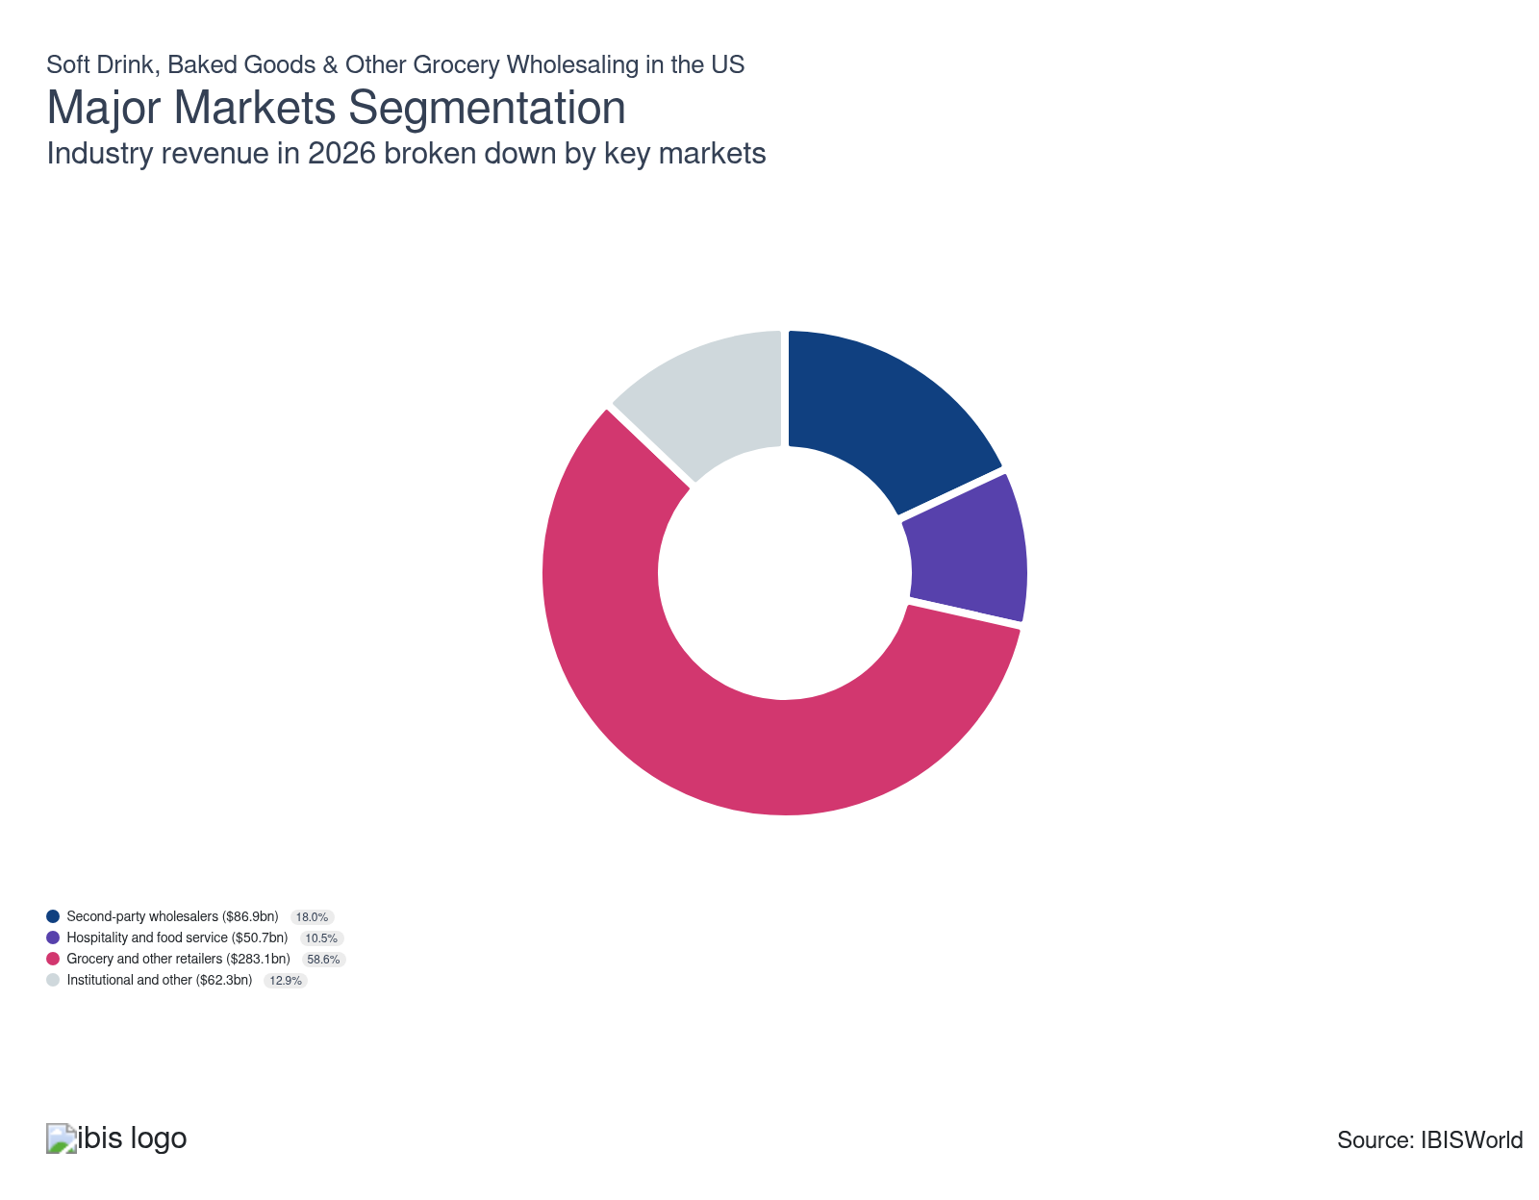

What’s influencing demand from the industry’s markets?

Grocery and other retailers shape wholesale dynamics
- Supermarket chains, grocery stores, convenience stores and specialty shops are primary retail outlets for diverse food, beverages and household items. These establishments vary in size and scope, from major national chains like Walmart and Kroger to small, niche shops concentrating on specific product categories or locally sourced goods.
- The rise in online grocery shopping has driven retailers to invest significantly in digital infrastructure, transforming inventory management and distribution models. This shift impacts wholesaler demand by requiring more flexible and efficient logistics solutions to match the fast-paced e-commerce environment. Wholesalers must adapt to these changes to support retailers effectively, leveraging digital tools and technologies to ensure timely and accurate delivery to meet consumer expectations.
- The increasing demand for healthier, organic and sustainably sourced retail products pushes wholesalers to modify their product lines accordingly. Retailers' emphasis on these categories drives wholesalers to align their offerings with consumer preferences, ensuring they remain competitive.
- Global supply chain disruptions, including transportation delays and ingredient shortages, have led retailers to prioritize finding more reliable and flexible wholesale partners. This shift affects order volumes and delivery schedules as retailers seek partners who can navigate uncertainties and provide consistent supply. In response, wholesalers must enhance their adaptability and communication strategies to maintain strong relationships with retailers amid these ongoing challenges.

Second-party wholesalers navigate shifting market demands
- Second-party wholesalers, such as those dealing in meat, dairy, fruits and vegetables, frozen food and general-line grocery items, act as intermediaries between manufacturers and retailers, ensuring a steady supply of diverse products to meet consumer demand.
- Ongoing supply chain disruptions, like transportation bottlenecks and raw material shortages, compel wholesalers to diversify sourcing strategies and optimize logistics. These adjustments are crucial to maintaining consistent inventory levels but can lead to increased costs and longer delivery times. Wholesalers who successfully navigate these challenges may enhance their resilience and adaptability, ultimately supporting more reliable supply chains and customer satisfaction.
- Tighter food safety and labeling regulations are compelling wholesalers to invest significantly in compliance measures, traceability systems and quality control processes. These requirements impact operational costs and efficiency as wholesalers adjust to meet new standards and ensure their product chains remain transparent and accountable.
- Adopting advanced technologies, like warehouse automation and inventory management software, enhances operational efficiency and accuracy, allowing wholesalers to better meet retailer demands and reduce waste.

Hospitality and food service trends reshape wholesale supply
- The hospitality and food service industry includes a wide range of businesses, such as restaurants, hotels, cafes and catering services, dedicated to providing food and beverages to customers. This sector depends on a steady supply of both fresh and packaged goods to satisfy varied consumer demands.
- The growing focus on sustainability in the hospitality sector is boosting demand for eco-friendly and ethically sourced products. In response, wholesalers must diversify their offerings to include more sustainable options, which is affecting their sourcing and inventory practices. This trend not only influences what products are available but also reshapes the supply chain to align with environmentally conscious values.
- Ongoing labor shortages in the hospitality industry are impacting operational efficiency and altering ordering patterns. As a result, wholesalers increasingly offer convenient, pre-prepared and easy-to-use products to help streamline food service operations. This shift aims to alleviate some of the operational pressures faced by businesses in the sector, enabling them to maintain service standards despite staffing challenges.
- The growth of technology in the hospitality sector, including online ordering and delivery services, is changing demand dynamics. In response, wholesalers need to enhance their logistics and distribution capabilities to guarantee timely and accurate deliveries. This adaptation is crucial to keeping pace with the shifting landscape and meeting the market's expectations of tech-driven convenience.

Schools, hospitals, prisons and government facilities keep a strong relationship with grocery wholesalers
- Schools, hospitals, prisons and other government facilities operate as public institutions that deliver education, healthcare, correctional services and other functions. They demand consistent and substantial supplies of food and beverages to serve large populations daily. This necessity underscores the importance of reliable supply chains to effectively meet their ongoing operational needs.
- Government facilities frequently function under stringent budget constraints, significantly influencing purchasing decisions. Wholesalers must provide competitive pricing and cost-effective solutions to accommodate these financial limitations. This approach ensures they can meet the needs of these institutions while adhering to budgetary restrictions.
- Consistent and reliable food supplies are crucial for government facilities, prompting wholesalers to focus on dependable logistics and inventory management. By doing so, they aim to prevent service disruptions, ensuring that these institutions can continuously meet the needs of their populations without interruption.
- Government facilities often make bulk purchases, requiring wholesalers to supply large quantities of products at discounted rates. This purchasing trend influences wholesalers' pricing strategies and inventory management practices, as they must adjust to offer competitive pricing while maintaining efficient stock levels.

International Trade

Some industries don't directly import or export goods. See reports at the manufacturing level for international trade data on relevant products.

5. Geographic Breakdown
https://my.ibisworld.com/us/en/industry/42449/geographic-breakdown

Key Takeaways
- Population concentration drives location choices. Regions with major metropolitan areas are home to several wholesalers because of their access to end markets.
- Access to shipping routes minimizes transportation costs. Wholesalers seek to minimize the cost of moving goods from upstream customers to downstream markets.

Business Locations
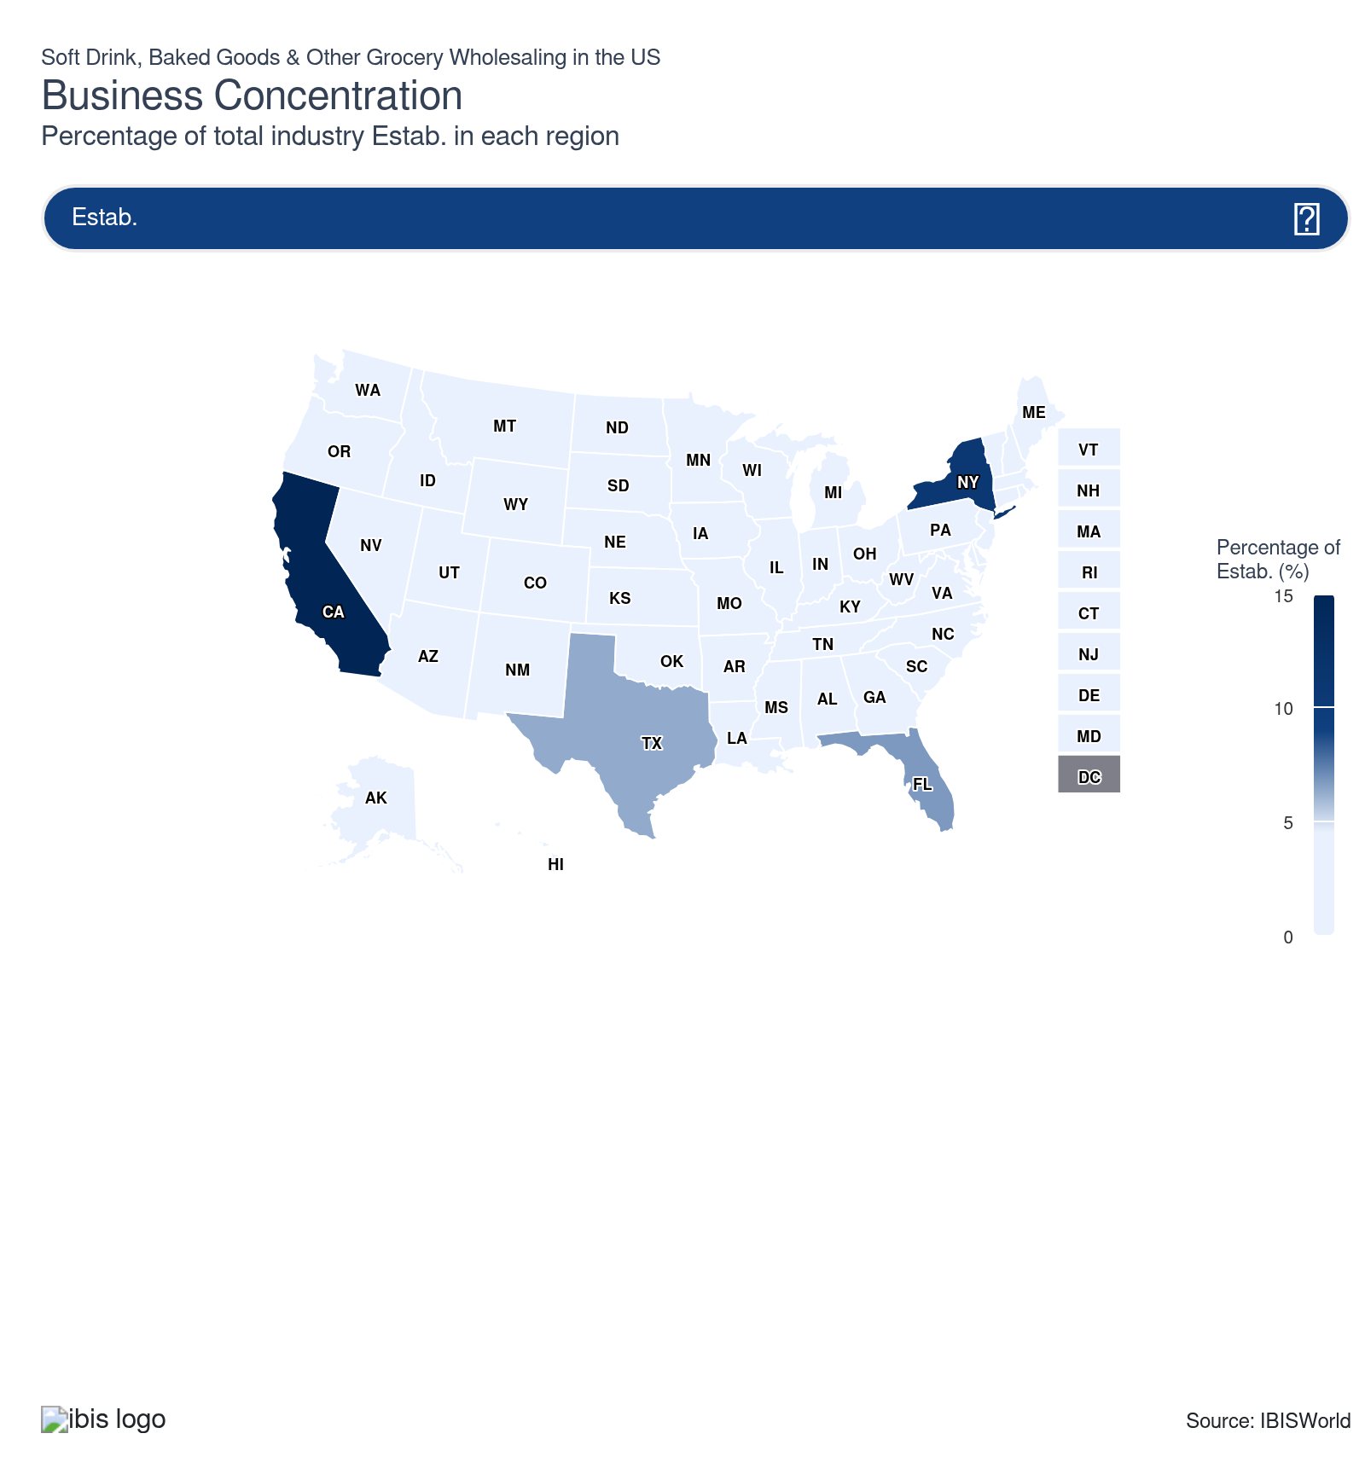
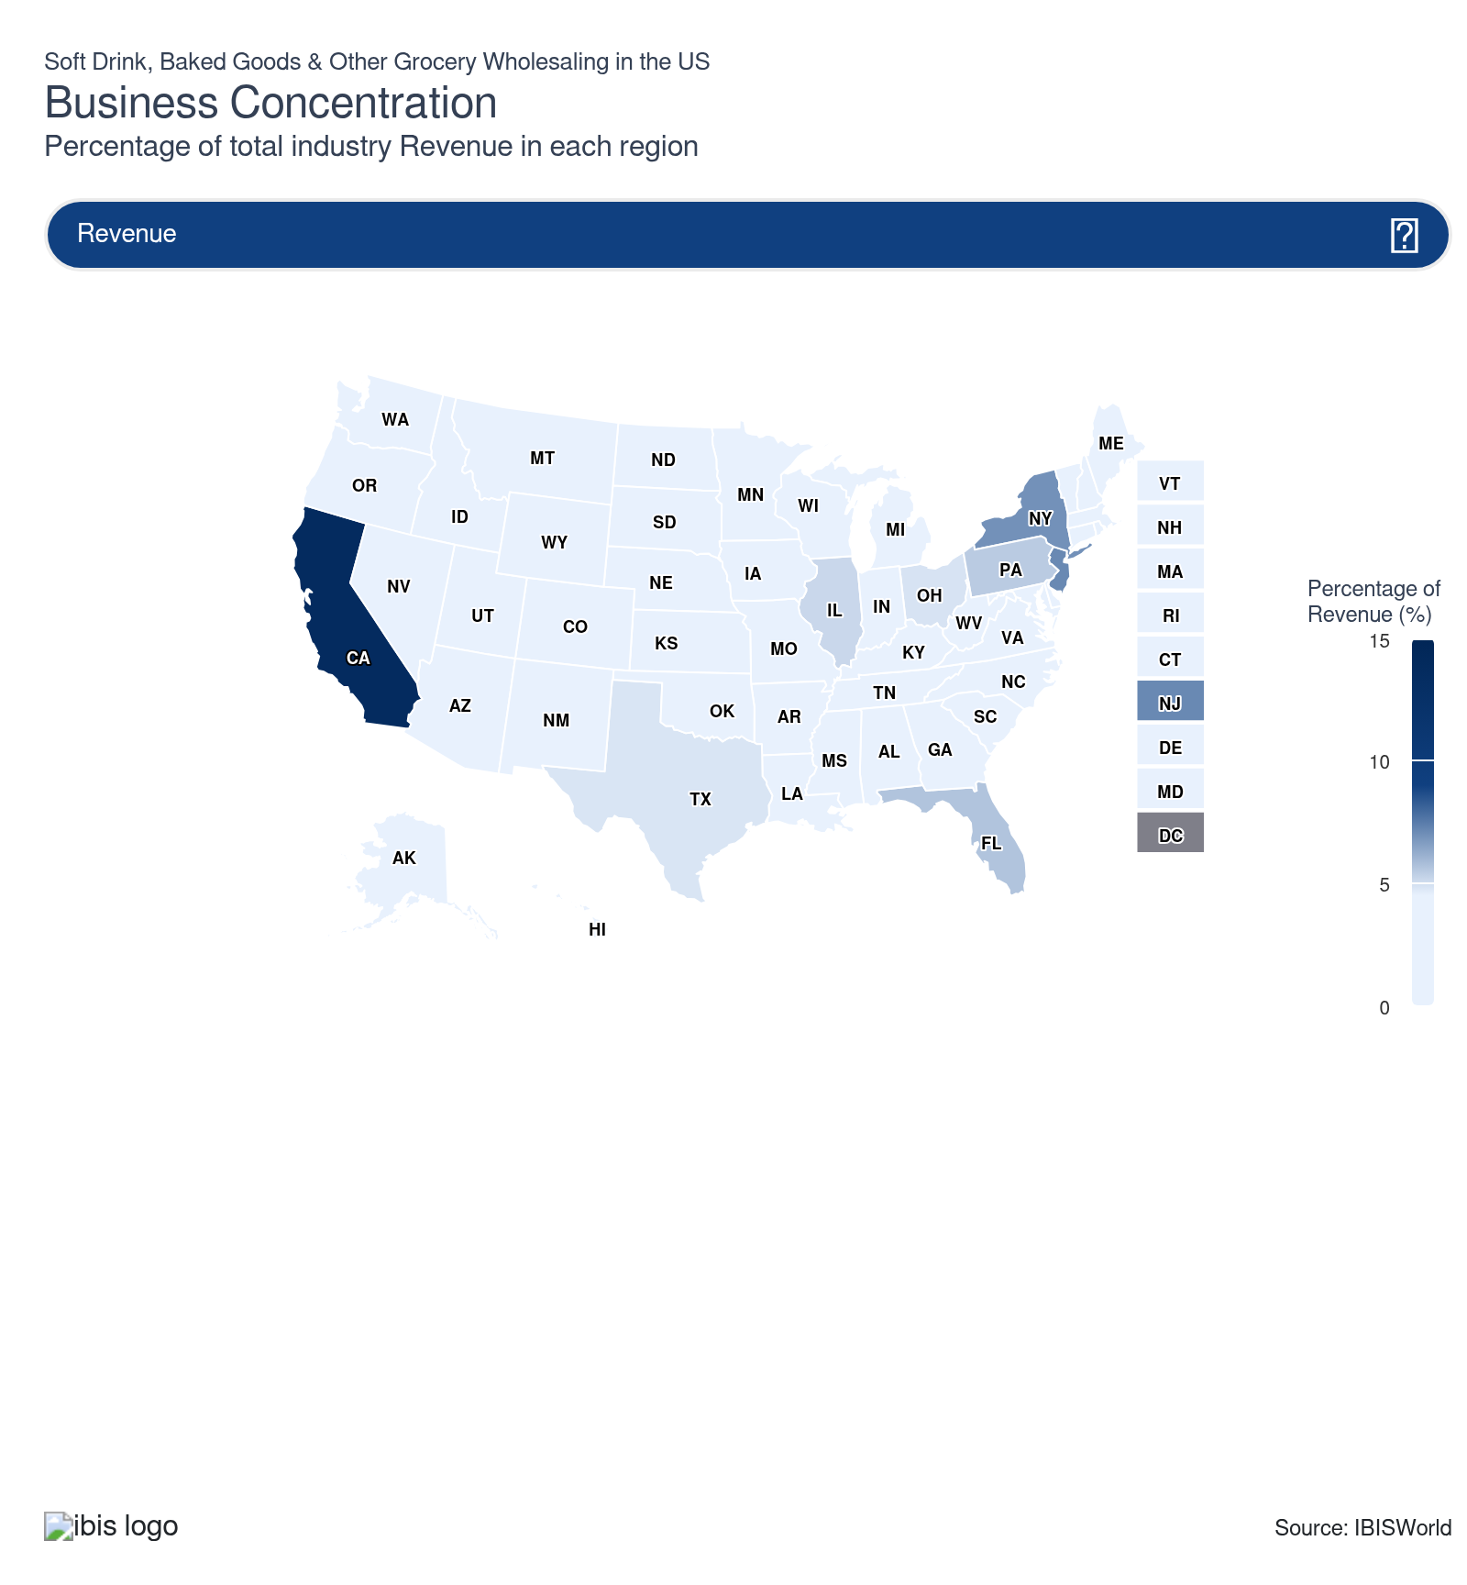
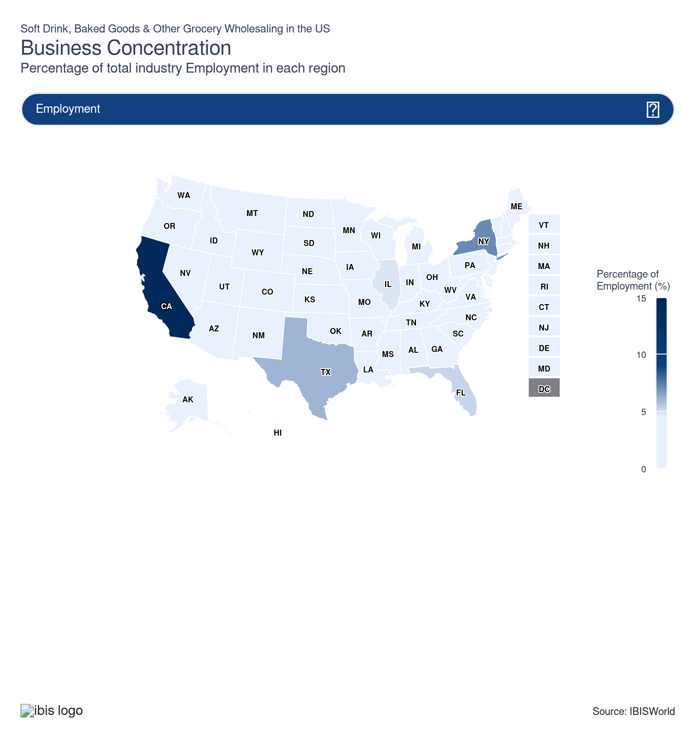
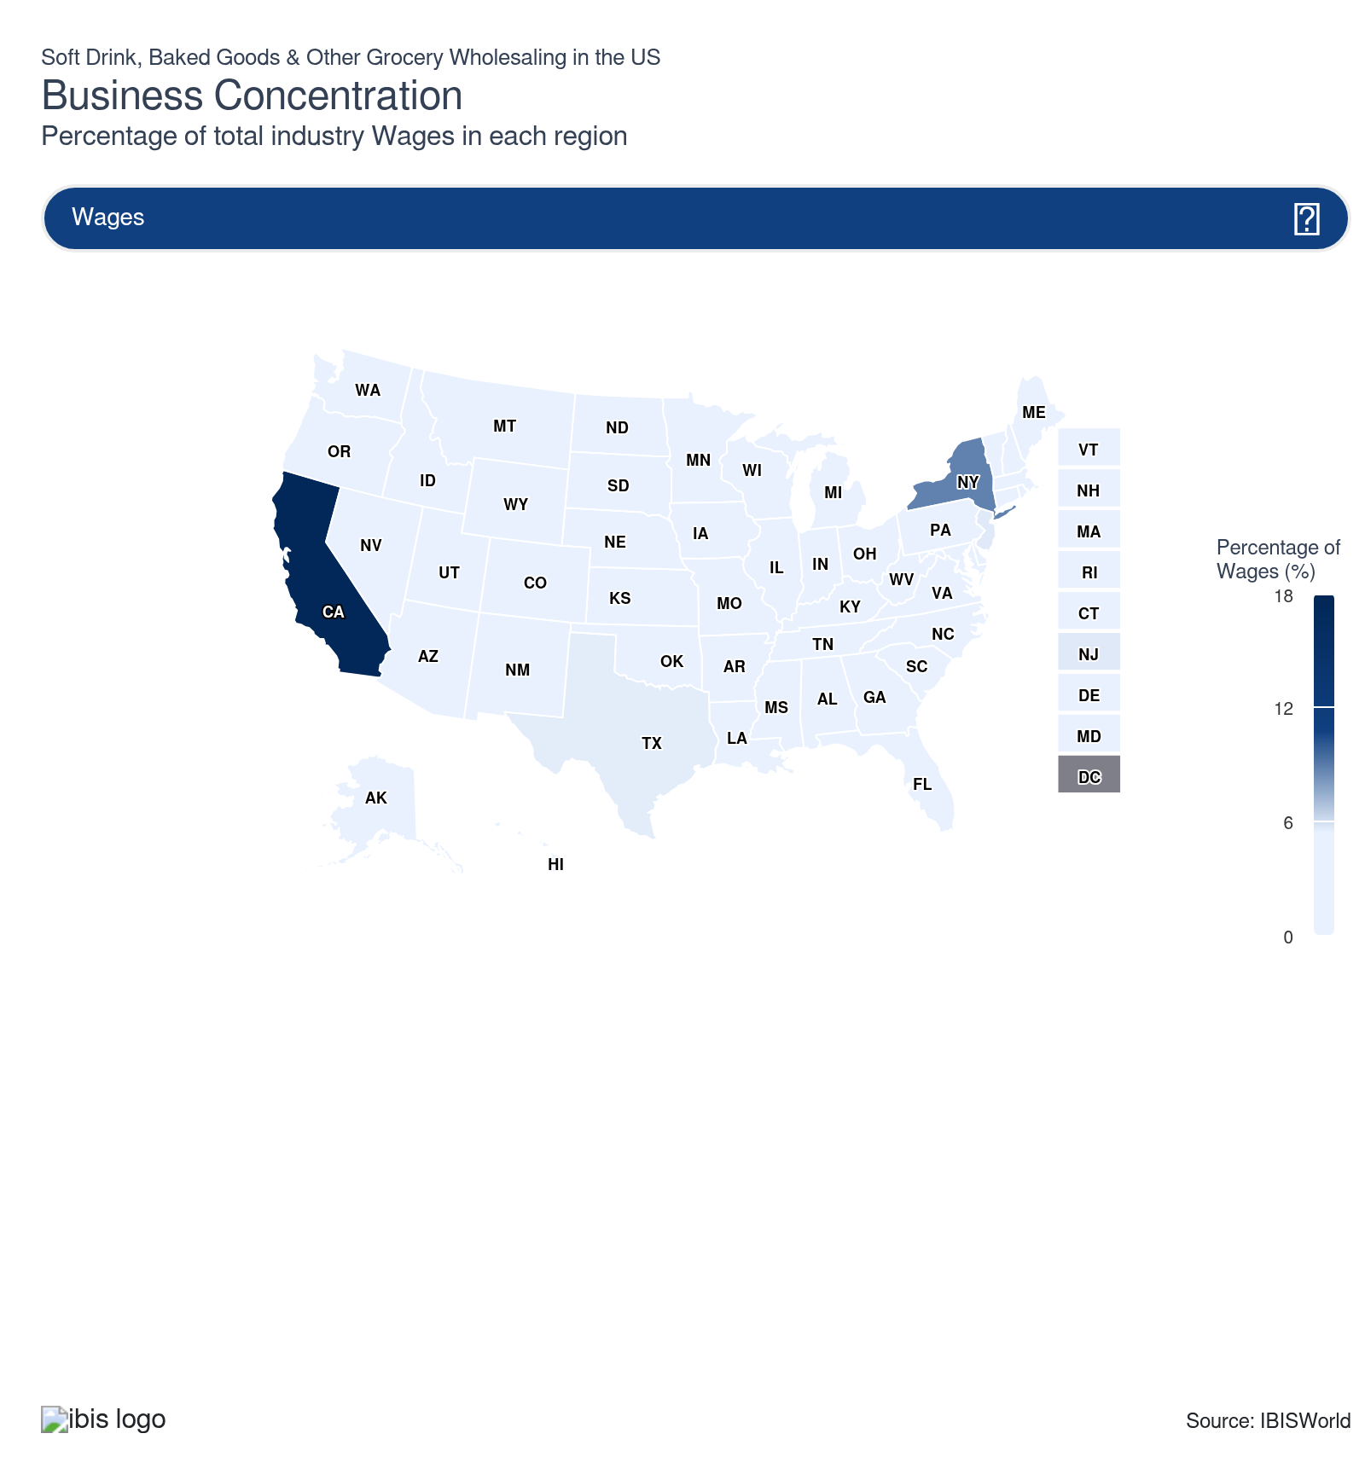
State | Estab.  Units | Estab.  % | Revenue  $m | Revenue  % | Wages  $m | Wages  % | Employment  Units | Employment  % | Population  %
California | 4,204 | 15.1 | 66,478.3 | 13.8 | 4,257.3 | 17.5 | 51,102 | 14.4 | 11.5
New Jersey | 1,242 | 4.4 | 34,564.9 | 7.2 | 1,369.3 | 5.6 | 15,808 | 4.4 | 2.8
New York | 3,066 | 11.0 | 33,524.9 | 6.9 | 2,133.7 | 8.8 | 25,328 | 7.1 | 5.8
Florida | 1,882 | 6.7 | 27,307.1 | 5.7 | 1,099.4 | 4.5 | 18,520 | 5.2 | 7.0
Texas | 1,758 | 6.3 | 23,264.1 | 4.8 | 1,340.3 | 5.5 | 21,402 | 6.0 | 9.4
Pennsylvania | 823 | 2.9 | 26,404.6 | 5.5 | 997.7 | 4.1 | 15,768 | 4.4 | 3.8
Illinois | 1,129 | 4.0 | 24,907.3 | 5.2 | 1,303.6 | 5.4 | 16,993 | 4.8 | 3.7
Ohio | 710 | 2.5 | 23,424.9 | 4.8 | 754.2 | 3.1 | 12,131 | 3.4 | 3.5
Georgia | 780 | 2.8 | 16,151.9 | 3.3 | 708.1 | 2.9 | 10,732 | 3.0 | 3.3
Connecticut | 308 | 1.1 | 18,011.2 | 3.7 | 679.5 | 2.8 | 6,963 | 2.0 | 1.1
Michigan | 740 | 2.6 | 9,755.2 | 2.0 | 579.6 | 2.4 | 8,862 | 2.5 | 3.0
Minnesota | 409 | 1.5 | 17,974.4 | 3.7 | 353.9 | 1.5 | 5,205 | 1.5 | 1.7
Washington | 704 | 2.5 | 8,992.7 | 1.9 | 536.4 | 2.2 | 7,877 | 2.2 | 2.3
North Carolina | 658 | 2.4 | 10,843.1 | 2.2 | 481.7 | 2.0 | 8,346 | 2.3 | 3.3
Massachusetts | 427 | 1.5 | 10,417.5 | 2.2 | 671.5 | 2.8 | 7,454 | 2.1 | 2.1
Arkansas | 272 | 1.0 | 14,904.4 | 3.1 | 222.9 | 0.9 | 3,475 | 1.0 | 0.9
Nebraska | 176 | 0.6 | 13,007.6 | 2.7 | 175.3 | 0.7 | 2,726 | 0.8 | 0.6
Colorado | 581 | 2.1 | 5,540.2 | 1.1 | 352.4 | 1.5 | 5,289 | 1.5 | 1.8
Arizona | 501 | 1.8 | 9,564.5 | 2.0 | 355.0 | 1.5 | 5,986 | 1.7 | 2.2
Virginia | 461 | 1.7 | 7,825.8 | 1.6 | 412.2 | 1.7 | 7,046 | 2.0 | 2.6
Tennessee | 419 | 1.5 | 8,694.3 | 1.8 | 455.1 | 1.9 | 6,973 | 2.0 | 2.1
Maryland | 446 | 1.6 | 6,812.3 | 1.4 | 471.5 | 1.9 | 6,915 | 1.9 | 1.8
Wisconsin | 434 | 1.6 | 5,917.6 | 1.2 | 369.5 | 1.5 | 6,100 | 1.7 | 1.7
Indiana | 408 | 1.5 | 6,874.3 | 1.4 | 432.6 | 1.8 | 6,309 | 1.8 | 2.0
Alabama | 308 | 1.1 | 5,436.5 | 1.1 | 342.6 | 1.4 | 6,561 | 1.8 | 1.5
Missouri | 397 | 1.4 | 7,581.5 | 1.6 | 366.9 | 1.5 | 6,019 | 1.7 | 1.8
Oregon | 384 | 1.4 | 4,224.7 | 0.9 | 256.0 | 1.1 | 4,573 | 1.3 | 1.2
South Carolina | 332 | 1.2 | 5,085.0 | 1.1 | 224.9 | 0.9 | 4,821 | 1.4 | 1.6
Louisiana | 314 | 1.1 | 5,099.4 | 1.1 | 227.4 | 0.9 | 4,681 | 1.3 | 1.3
Nevada | 273 | 1.0 | 3,157.5 | 0.7 | 164.0 | 0.7 | 2,787 | 0.8 | 1.0
Kentucky | 233 | 0.8 | 4,169.8 | 0.9 | 213.3 | 0.9 | 4,436 | 1.2 | 1.3
Kansas | 165 | 0.6 | 3,755.9 | 0.8 | 202.4 | 0.8 | 3,991 | 1.1 | 0.9
Oklahoma | 271 | 1.0 | 3,535.2 | 0.7 | 157.9 | 0.7 | 3,463 | 1.0 | 1.2
Iowa | 233 | 0.8 | 3,352.4 | 0.7 | 135.3 | 0.6 | 2,905 | 0.8 | 0.9
Utah | 187 | 0.7 | 2,027.8 | 0.4 | 145.6 | 0.6 | 3,185 | 0.9 | 1.0
Mississippi | 205 | 0.7 | 1,790.5 | 0.4 | 108.2 | 0.4 | 2,815 | 0.8 | 0.9
North Dakota | 93 | 0.3 | 1,711.7 | 0.4 | 54.7 | 0.2 | 1,397 | 0.4 | 0.2
Idaho | 156 | 0.6 | 1,345.9 | 0.3 | 49.1 | 0.2 | 1,185 | 0.3 | 0.6
Hawaii | 118 | 0.4 | 1,384.4 | 0.3 | 56.9 | 0.2 | 1,410 | 0.4 | 0.4
New Hampshire | 116 | 0.4 | 1,304.9 | 0.3 | 72.4 | 0.3 | 1,230 | 0.3 | 0.4
Vermont | 75 | 0.3 | 1,534.2 | 0.3 | 62.3 | 0.3 | 1,339 | 0.4 | 0.2
Montana | 140 | 0.5 | 737.4 | 0.2 | 41.8 | 0.2 | 1,196 | 0.3 | 0.3
West Virginia | 91 | 0.3 | 1,424.8 | 0.3 | 48.3 | 0.2 | 1,214 | 0.3 | 0.5
South Dakota | 132 | 0.5 | 696.4 | 0.1 | 36.1 | 0.1 | 1,134 | 0.3 | 0.3
Maine | 128 | 0.5 | 954.7 | 0.2 | 48.3 | 0.2 | 1,003 | 0.3 | 0.4
Rhode Island | 95 | 0.3 | 1,366.7 | 0.3 | 43.6 | 0.2 | 797 | 0.2 | 0.3
New Mexico | 116 | 0.4 | 813.4 | 0.2 | 36.0 | 0.1 | 1,024 | 0.3 | 0.6
Delaware | 109 | 0.4 | 602.2 | 0.1 | 36.4 | 0.2 | 645 | 0.2 | 0.3
Alaska | 70 | 0.3 | 543.0 | 0.1 | 44.2 | 0.2 | 819 | 0.2 | 0.2
Wyoming | 87 | 0.3 | 284.5 | 0.1 | 22.5 | 0.1 | 666 | 0.2 | 0.2

Where are industry businesses located?

Population density is key in the Mid-Atlantic region
- The Mid-Atlantic region is part of the densely populated Northeast megaregion, where major urban centers like New York City and Philadelphia group together residents, employment opportunities, and infrastructure in a tight corridor. This concentration supports robust, consistent demand trends that appeal to wholesalers providing food, beverage, and daily necessities.
- Crowded urban and suburban areas result in closely grouped downstream markets, featuring numerous households and businesses situated within relatively brief delivery distances. This provides a competitive edge for wholesalers who can dominate local routes and facilitate high-frequency, small-drop replenishment strategies.
- The concentration of population further enhances the effects of strategically positioning facilities. Placing distribution centers close to key hubs enables wholesalers to access a broad customer base swiftly, facilitating shorter delivery times, fresher goods, and improved service, while also maintaining manageable transportation and labor expenses.
- In these crowded markets, wholesalers can divide their offerings and service models by neighborhood, retailer type, and channel, customizing assortments and delivery methods to fit local demographics. This geographic accuracy enhances retailer partnerships, increases market penetration, and aids in safeguarding market share against rivals focusing on the same concentrated demand.

The West has proximity to upstream suppliers and downstream consumers
- Access to the coast in the West links ports straight to global shipping routes, reducing lead times between international suppliers and inland markets. This location aids in reducing logistics expenses and renders the area particularly appealing for distribution activities focused on imports and exports that depend on swift ocean-intermodal links.
- Intensive agricultural and food-processing operations, especially in Western farming areas, secure the grocery supply chain near the source. Proximity to these production centers allows for fresher, more dependable supplies of perishables, lowering spoilage risks and facilitating tighter delivery timelines for retailers and foodservice clients.
- Wholesalers positioned near major production regions can swiftly adapt to changes in demand, modify loads according to crop conditions and work closely with growers and manufacturers. Reduced distances from plant or field to warehouse increase flexibility, lower fuel consumption, and facilitate more regular restocking cycles.
- Closeness to upstream producers and major Western population hubs enables distributors to maintain cost-effectiveness while ensuring high service quality. By connecting production areas and compact consumer markets through strategically located facilities, wholesalers can enhance inventory placement, assist multi-channel clients, and bolster resilience against regional disruptions.

Stellar growth opportunities for grocery wholesaling in the Southeast
- The Southeast serves as a national logistics center, with cities like Atlanta and Memphis and ports like Savannah, allowing wholesalers quick access to regional and national markets via extensive highway, rail and air systems. This system enables effective grocery distribution and quick restocking.
- Robust in-migration and household establishment in states such as Florida, Georgia and the Carolinas are further enlarging the area’s consumer market, particularly in rapidly developing metropolitan areas. Increasing demand for essential grocery items and convenience foods presents an opportunity for wholesalers to strengthen connections with retailers and foodservice operators.
- Widespread economic expansion and continuous industrial investment, encompassing manufacturing and logistics initiatives, are strengthening the Southeast’s position as a hub for production and distribution. With the launch of new facilities, wholesalers can either co-locate or form partnerships in proximity, enhancing the reliability of inbound supply and facilitating just-in-time delivery to downstream clients.
- Policies that favor business, cost-effective operations, and abundant industrial properties facilitate the expansion or relocation of wholesalers' distribution centers in the area. These structural benefits establish the Southeast as a long-term growth area for grocery wholesaling, facilitating scalable networks that cater to local markets and the wider Sun Belt region.
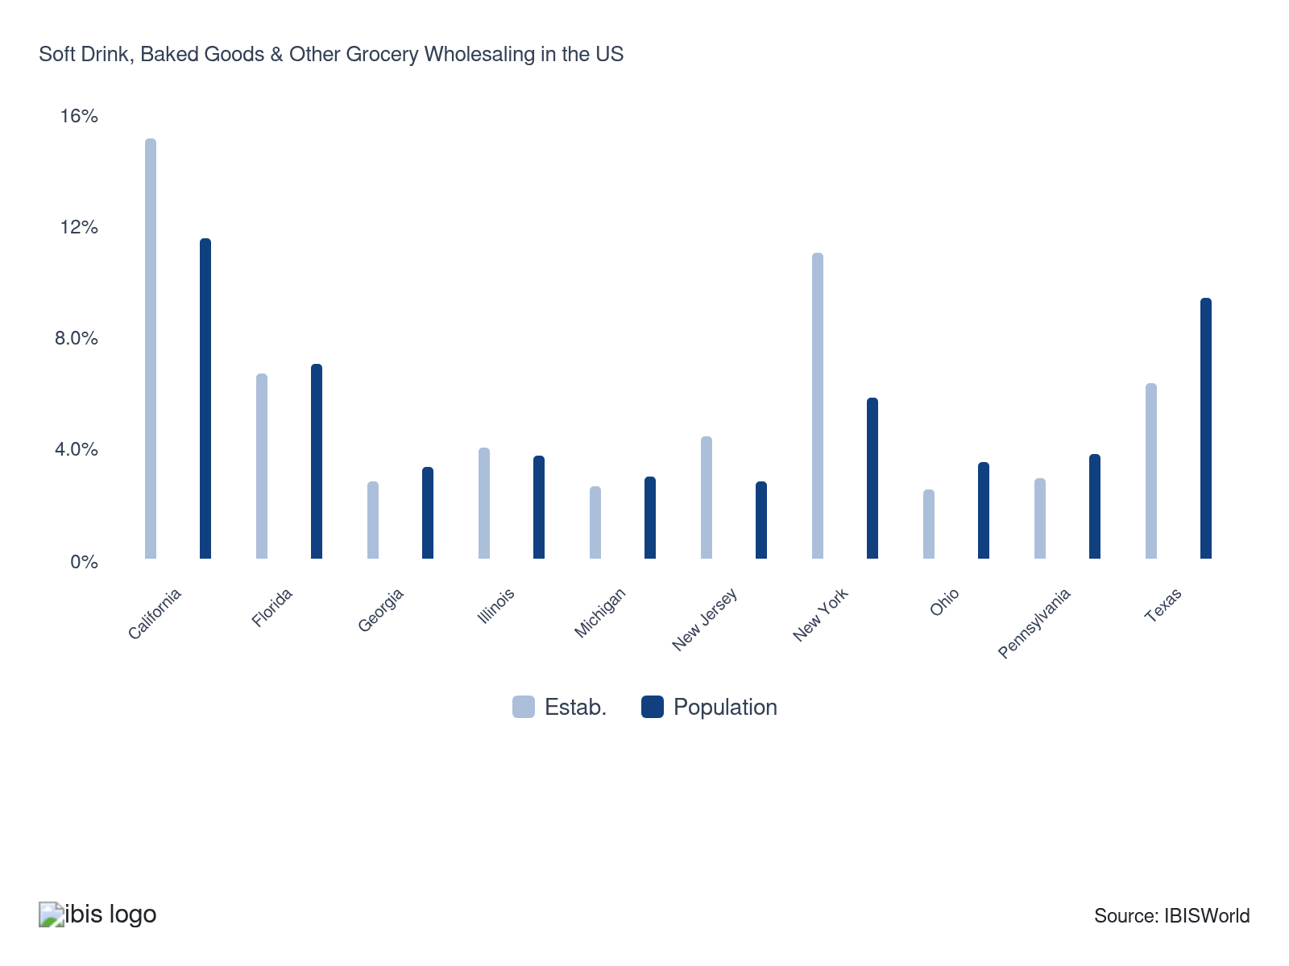

How do businesses use location to their advantage?
Prompt delivery to market
Grocery products are perishable goods. Prompt delivery ensures that the products are in the best possible state for retail sale and consumption.
Proximity to key markets
Successful wholesalers are located near their key retail markets to save on transportation costs and ensure prompt delivery.

6. Competitive Forces
https://my.ibisworld.com/us/en/industry/42449/competitive-forces

Key Takeaways
- Companies provide value through additional services. Large retailers collaborate with wholesalers to ensure accurate and timely order fulfillment, enhancing customer satisfaction and operational efficiency.
- Manufacturers have become a direct source of retailers' inventory. This trend increasingly bypasses wholesalers, streamlining the supply chain and reducing intermediaries.

Concentration
Low
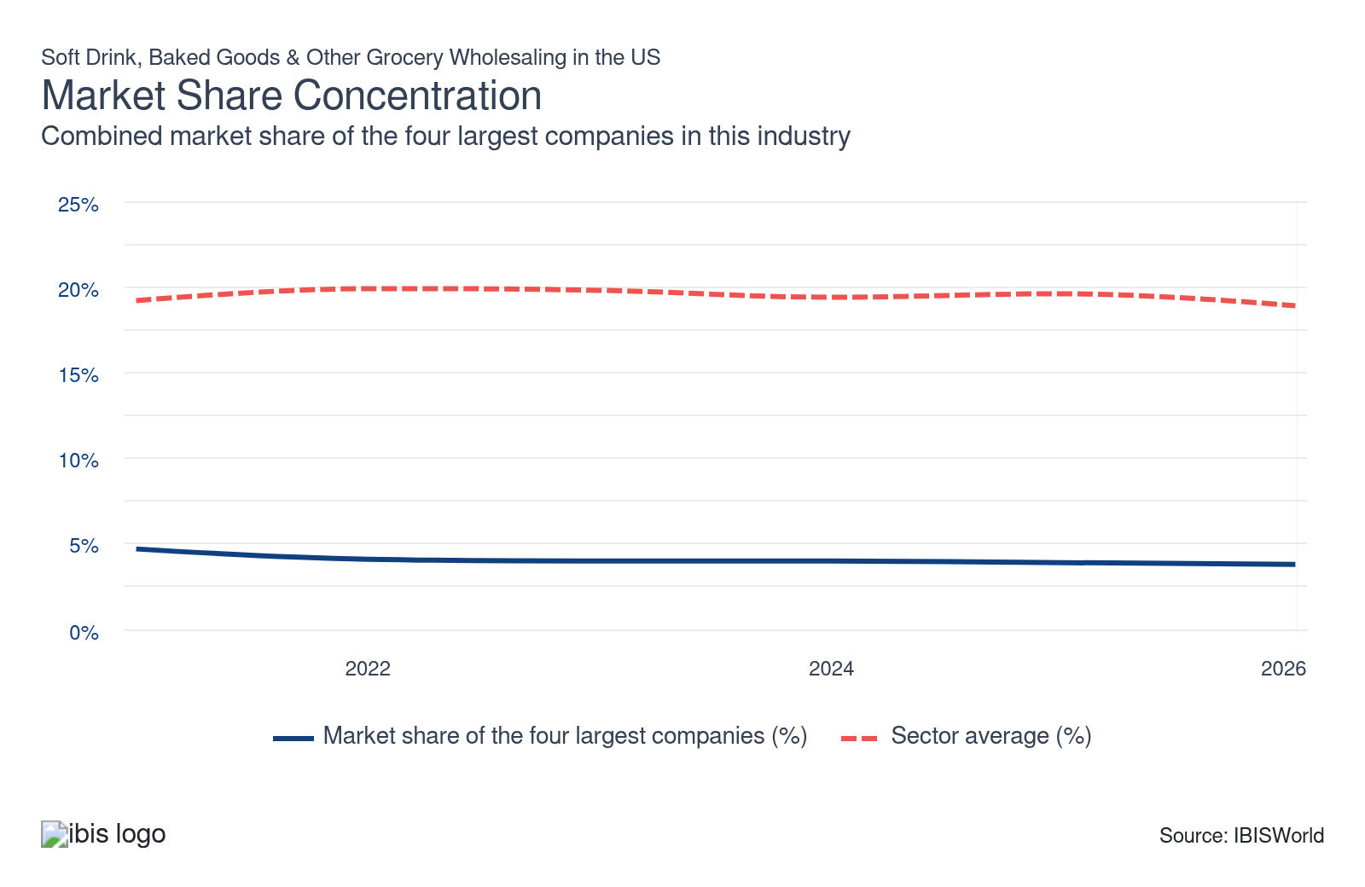

What impacts the industry’s market share concentration?

Fragmented customer bases keep national dominance out of reach
- The industry caters to a diverse client range, from independent grocers to convenience stores, which prevents any single entity from dominating nationwide. The wide variety of customer needs across regions limits the scalability of larger firms.
- Hyper-local preferences drive many clients towards wholesalers who understand specific product requirements, giving smaller regional companies an advantage. This preference for localized service makes it challenging for large corporations to establish uniform national reach and loyalty.
- Local and regional wholesalers often excel by building enduring relationships with nearby retailers and food service companies. They provide tailored services, flexible delivery options and personal support, aspects that national businesses struggle to match consistently.
- Consequently, the market remains highly fragmented, with no dominant player. Large entities like UNFI and Performance Food Group often specialize in particular categories or regions, emphasizing the difficulty of achieving widespread control.

Low barriers to entry make room for countless small companies
- The soft drink and baked goods distribution sectors require minimal capital investment and no proprietary technology, enabling numerous small-scale entrants to compete, particularly in underserved local markets. This accessibility fuels a diverse and competitive landscape.
- Smaller wholesalers, often operating with lower overheads, provide personalized service that appeals to niche customers and mom-and-pop retailers. These clients value flexibility over scale, making small companies a preferred choice.
- Many products, like packaged snacks and shelf-stable beverages, are easy to store and transport, so even part-time or mobile distributors can succeed without extensive infrastructure. This ease of entry supports a wide array of independent businesses.
- The fragmented market, featuring hundreds of small wholesalers operating on thin margins, poses challenges for large companies attempting consolidation. Achieving wider market control often risks compromising service quality and efficiency, maintaining the industry's diversity.

Strong economies of scale coexist with relationship-driven advantages in this market
- Larger wholesalers have distinct cost benefits as they distribute expenses for trucking, warehousing, cold storage and IT across high volumes, enabling them to secure better pricing and stricter service-level agreements with prominent brands and national retailers. This scale enables them to conduct more automated, data-oriented operations and handle disruptions more effectively.
- However, numerous customers—particularly independents, regional chains, ethnic grocery stores and local foodservice providers—value flexibility, product variety and personal assistance more than sheer size. Distributors focused on relationships secure and retain these accounts by customizing product selections, accommodating minimum order exceptions, addressing issues promptly and grasping local preferences.
- Regional experts can delve further into segments such as bakery, beverages, or natural and organic, providing distinctive SKUs and quicker reactions than broadline national providers. Due to these service and specialization benefits balancing some of the major players’ cost advantages, market share is distributed among various levels of wholesalers rather than being concentrated solely at the top.

How do successful businesses handle concentration?
Secure economies of scale
Securing economies of scale is crucial for soft drink, baked goods and other grocery wholesalers in the US to enhance efficiency, lower per-unit costs and maintain their standing in the highly competitive wholesale industry.
Have a large supply contract
Having a large supply contract is essential for wholesalers to ensure stable inventory, negotiate favorable terms and maintain consistent product availability.

Barriers to Entry
Low | Steady

What challenges do potential industry entrants face?

Legal
- Companies entering this industry encounter few barriers, as there are no specific licensing requirements or government regulations apart from standard FDA guidelines and labor laws, such as minimum wage regulations. This openness can encourage innovation and competition, fostering a dynamic market landscape with diverse business opportunities for new entrants.

Start-Up Costs
- The high cost of establishing a warehouse and distribution system is a significant barrier, as businesses will need a large amount of space to store goods before distribution. The cost of attaining product stock, storage space, distribution infrastructure and facilities can deter companies from entering the industry.

Differentiation
- Wholesalers must build strong brand awareness in their markets and secure favorable long-term contracts with retailers. Achieving this can ensure a steady and reliable demand for their products, promoting business stability and growth. Effective marketing strategies and solid relationships with retailers are crucial for success in this competitive landscape.

Labor Expenses
- The industry relies on manual labor to organize, store and ship apparel. While computer systems are designed to monitor inventory levels and track sales, copious amounts of unskilled labor are required at each step.

How can potential entrants overcome barriers to entry?
Develop contacts within key markets
For ultimate success, wholesalers must establish and maintain strong, healthy relationships within retail markets, ensuring consistent communication to understand and meet retailers' needs and expectations.
Have a diverse range of clients
Maintaining a diverse range of clients is crucial for wholesalers to mitigate risks, tap into various market segments and ensure revenue stability.

Substitutes
Low | Steady

What are substitutes for industry services?

In-house
- Wholesalers are increasingly being edged out of the supply chain as manufacturers, producers and retailers opt for direct interactions. This shift is driven by a desire to minimize unnecessary transaction costs, making the supply chain more cost-effective and efficient.
- The trend, known as disintermediation, eliminates traditional middlemen, transforming the logistics landscape. By directly managing distribution, companies gain more control, streamlining processes and potentially passing savings onto consumers through reduced prices.
- This approach allows companies to maintain greater product oversight, enhance supply chain communication, and expedite responses to market demands. These advantages are reshaping supply chain strategies and influencing future business operations.

Healthy products
- A heightened health and nutrition awareness is reshaping consumer purchasing habits, leading to a declining demand for products like sodas and baked goods. This trend suggests a significant shift towards more health-oriented choices in the marketplace.
- Consumers increasingly gravitate towards healthier alternatives as they become more informed about nutritional content. This shift challenges the traditional dominance of processed soft drinks and baked goods, creating a demand for more nutritious options.
- The grocery wholesaling industry is witnessing a substantial impact as these healthier products gain popularity. Retailers and producers rapidly adapt to meet the growing consumer preference for nutritional value and healthier lifestyles.

How do successful businesses compete with substitutes?
Vary services to suit different needs
Successful wholesalers offer additional services, such as store planning, inventory control and marketing services, which they adjust to suit the needs of individual customers.
Secure economies of scale
Securing economies of scale is crucial for wholesalers to enhance efficiency, lower per-unit costs and maintain competitiveness in the highly competitive wholesale industry.

Buyer & Supplier Power
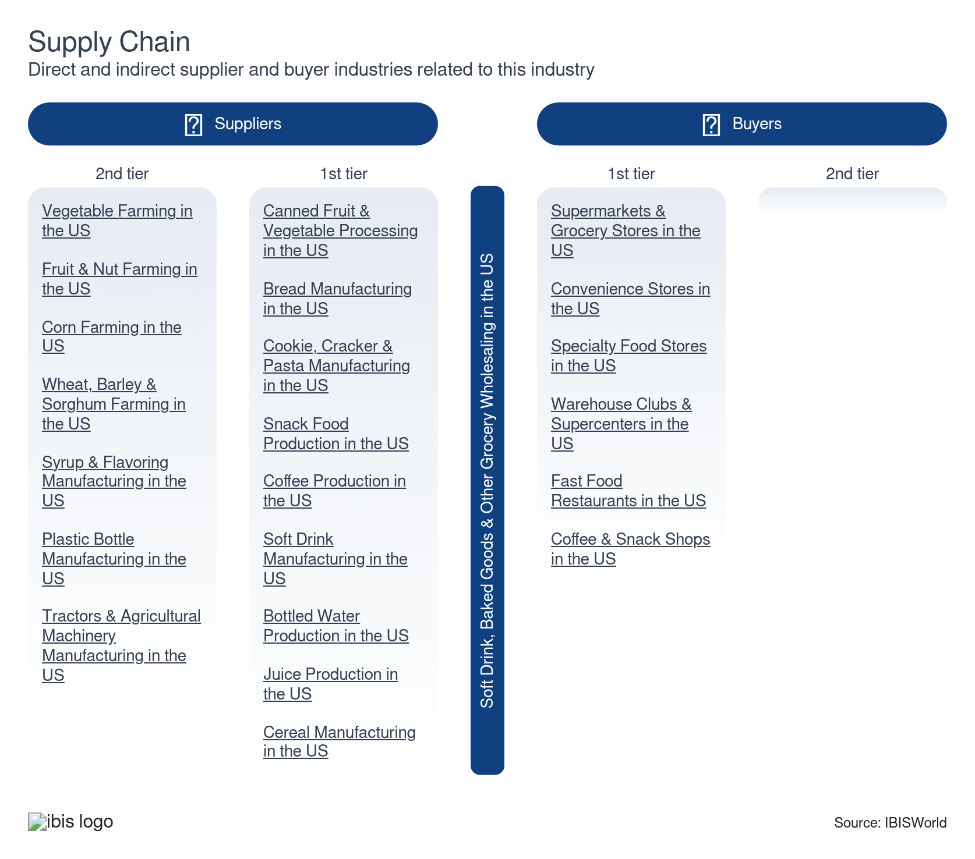

What power do buyers and suppliers have over the industry?

Buyers: Relationship-oriented
Moderate | Steady
- Wholesalers with an extensive range of product options often find greater success. Retail customers highly value the convenience of accessing multiple products from a single source and the consistent support provided across various locations. This broad selection effectively meets diverse customer needs, fostering loyalty and repeat business.
- Exclusive distribution rights are crucial in strengthening bonds between wholesalers and buyers. By securing these rights, wholesalers limit buyers' opportunities to explore alternative suppliers. This exclusivity offers a significant competitive edge, ensuring sustained business and collaboration in a competitive market landscape.
- Wholesalers that build strong, relationship-driven connections with their clients foster stability and repeat transactions. Retail clients prefer the tailored service and dependable support wholesalers offer, prioritizing long-term partnerships over short-term gains. Such emphasis on relationships enhances client satisfaction and market presence.

Suppliers: Few options
High | Increasing
- Distribution products largely originate from major producers, leaving wholesalers with few sourcing alternatives. The industry's intense price competition compels wholesalers to continuously negotiate for more favorable purchase prices, striving to maintain their margins amid challenging conditions.
- Manufacturers and suppliers are increasingly adopting strategies to bypass wholesalers, opting to market and sell directly to retailers. This direct sales approach enhances their profitability by allowing them to retain a greater revenue share, diminishing wholesalers' traditional roles in the supply chain.
- The shift towards direct manufacturer-to-retailer interactions is reshaping industry dynamics. Wholesalers find it difficult to compete because of reduced influence and fewer negotiation opportunities, challenging their ability to maintain competitive pricing and service offerings.

How do successful businesses manage buyer & supplier power?
Having contacts within key markets
For ultimate success, wholesalers must establish and maintain strong, healthy relationships within retail markets, ensuring consistent communication to understand and meet retailers' needs and expectations.
Ensure prompt delivery to market
Grocery products are perishable goods. Prompt delivery ensures the products are in the best possible state for retail sale and consumption.

7. Companies
https://my.ibisworld.com/us/en/industry/42449/companies

Key Takeaways
- Wholesalers operate on a regional or local basis. Typically, they specialize in a specific type of product because of the wide range of products included in this industry.
- Market dominance is limited by scale. Even Sysco, a behemoth multinational food distributor, controls just a sliver of the industry.

Market Share
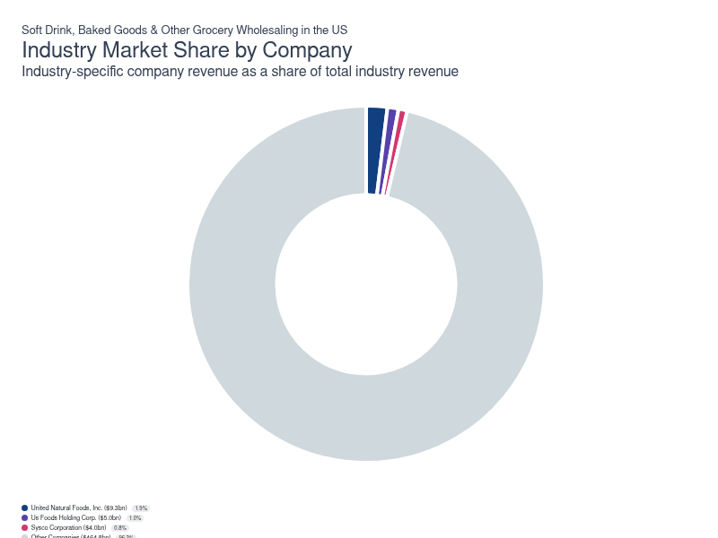
Chart displays current year only in the PDF version of this report. You can view and download chart for all other years associated with this industry on my.ibisworld.com.

Companies
Company | Market Share (%)  2026 | Revenue ($m)  2026 | Profit ($m)  2026 | Profit Margin (%)  2026
United Natural Foods, Inc. | 1.9 | 9,287.3 | 1,633.1 | 17.6
Us Foods Holding Corp. | 1.0 | 4,975.3 | 67.9 | 1.4
Sysco Corporation | 0.8 | 3,980.3 | 185.9 | 4.7

United Natural Foods, Inc.
United Natural Foods, Inc.
Company Details
Company Details
Industry Specific Revenue (2026) | $9.3bn
Industry Profit (2026) | $1.6bn
Company Employees (2026) | 28,300
Market Share (2026) | 1.9%

Description
Description
United Natural Foods is a public company headquartered in Rhode Island with an estimated 28,300 employees. In the US, the company has a notable market share in at least two industries: Grocery Wholesaling, Soft Drink, Baked Goods & Other Grocery Wholesaling and Soft Drink, Baked Goods & Other Grocery Wholesaling. Their largest market share is in the Grocery Wholesaling industry, where they account for an estimated 9.0% of total industry revenue and are considered a Rising Star because they display lower market share, but displaying stronger profit and revenue growth than some of their peers.

Brands and Trading Names
Brands and Trading Names
- Blue Marble
- Community marketplace
- Honest Green
- Pro Organics
- Tony's Fine Foods
- UNFI
- UNFI Brands
- UNFI Canada
- UNFI Fresh
- UNFI Norcal
- UNFI produce
- UNFI Up Next
- UNFI wellness
- Woodstock Farms

Other Industries
Other Industries
- Grocery Wholesaling in the US

Company’s Industry Revenue, Market Share, and Profit Margin Over Time
Company’s Industry Revenue, Market Share, and Profit Margin Over Time
Year | Industry Revenue ($ million) | Market Share (%) | Profit Margin (%)
2016 | 5885 | 1.9 | 0.7
2017 | 6262 | 2.0 | 0.7
2018 | 6765 | 2.1 | 0.7
2019 | 7362 | 2.2 | 0.7
2020 | 8040 | 2.3 | 0.7
2021 | 9287 | 2.4 | 17.6
2022 | 9287 | 2.1 | 17.6
2023 | 9287 | 2.0 | 17.6
2024 | 9287 | 2.0 | 17.6
2025 | 9287 | 2.0 | 17.6
2026 | 9287 | 1.9 | 17.6

What's impacting United Natural Foods, Inc.'s performance?

Woodstock introduces new line of hot sauce
- Woodstock, which is a brand under United Natural Foods Inc., introduced a new line of hot sauces. One motivation for this product expansion is that hot sauce sales have grown 30% in 2020, as the Chief Marketing Officer at United Natural Foods Inc. stated. The new hot sauce line includes four flavours.

United Natural Foods invests in renewable energy
- United Natural Foods Inc. made the company’s largest investment in renewable energy. In collaboration with solar project developer, Pine Gates Renewables, it is investing in Trent River Solar, a 108.5 megawatt solar facility. The site will contain over 800,000 solar panels and create enough energy to provide power to over 14,000 homes.

United Natural Foods adopts technology to reduce emissions
- United Natural Foods Inc. adopted emerging transportation technology to reduce emissions. UNFI is adding 53 electric transport refrigerated trailer units to its fleet located at a distribution center. This is part of the Better for All 2030 Environmental, Social and Governance (ESG) agenda. UNFI is one of the first wholesalers to use this innovative technology.
Us Foods Holding Corp.
Us Foods Holding Corp.
Company Details
Company Details
Industry Specific Revenue (2026) | $5.0bn
Industry Profit (2026) | $67.9m
Company Employees (2026) | 30,000
Market Share (2026) | 1.0%

Description
Description
Us Foods Holding is a public company headquartered in Illinois with an estimated 30,000 employees. In the US, the company has a notable market share in at least three industries: Grocery Wholesaling, Fish & Seafood Wholesaling, Soft Drink, Baked Goods & Other Grocery Wholesaling and Soft Drink, Baked Goods & Other Grocery Wholesaling. Their largest market share is in the Fish & Seafood Wholesaling industry, where they account for an estimated 28.8% of total industry revenue and are considered an All Star because they display stronger market share, profit and revenue growth compared to their peers.

Brands and Trading Names
Brands and Trading Names
- Chef's Line
- Metro Deli
- Rykoff Sexton
- Stock Yards

Other Industries
Other Industries
- Fish & Seafood Wholesaling in the US
- Grocery Wholesaling in the US

Company’s Industry Revenue, Market Share, and Profit Margin Over Time
Company’s Industry Revenue, Market Share, and Profit Margin Over Time
Year | Industry Revenue ($ million) | Market Share (%) | Profit Margin (%)
2016 | 3565 | 1.2 | -0.3
2017 | 3806 | 1.2 | -0.3
2018 | 4231 | 1.3 | -0.3
2019 | 4660 | 1.4 | -0.3
2020 | 5226 | 1.5 | -0.3
2021 | 4975 | 1.3 | 1.4
2022 | 4975 | 1.1 | 1.4
2023 | 4975 | 1.1 | 1.4
2024 | 4975 | 1.1 | 1.4
2025 | 4975 | 1.1 | 1.4
2026 | 4975 | 1.0 | 1.4

What's impacting Us Foods Holding Corp.'s performance?

US Foods announces new sustainability initiatives
- In March 2022, US Foods announced new sustainability initiatives that will help the company reach its goal of reducing carbon footprint of its delivery fleet. US Foods is planning on converting fuel at all California distribution centers from traditional diesel to renewable diesel by mid-2022. Renewable diesel is more sustainable as it has a 65.0% lower carbon intensity rating. The company is also planning on adding 30 electric trucks specifically to its distribution center in La Mirada, California by end of 2023. These initiatives will help US Foods complete its goal of reducing scope 1 and scope 2 emission intensities.

US Foods acquires Smart Foodservice Warehouse Stores
- In 2020, US Foods completed the acquisition of Smart Foodservice Warehouse Stores for $970.0 million. Previously owned by Apollo Global Management, Smart Foodservice Warehouse Stores operate 70 small-format cash and carry stores across Montana, Utah, Nevada, Idaho, California, Oregon and Washington. Smart Foodservices Warehouse Stores mainly serve small and mid-sized restaurants and other food business customers. The acquisition complements US Foods’ CHEF’STORE cash and carry model, as well as significantly increases the company’s presence in the West Coast.
Sysco Corporation
Sysco Corporation
Company Details
Company Details
Industry Specific Revenue (2026) | $4.0bn
Industry Profit (2026) | $185.9m
Company Employees (2026) | 76,000
Market Share (2026) | 0.8%

Description
Description
Sysco is a public company headquartered in Texas with an estimated 76,000 employees. In the US, the company has a notable market share in at least seven industries: Paper Bag & Disposable Plastic Product Wholesaling, Grocery Wholesaling, Packaged Frozen Food Wholesaling, Egg & Poultry Wholesaling, Fish & Seafood Wholesaling, Beef & Pork Wholesaling and Soft Drink, Baked Goods & Other Grocery Wholesaling. Their largest market share is in the Egg & Poultry Wholesaling industry, where they account for an estimated 32.1% of total industry revenue and are considered a Rising Star because they display lower market share, but displaying stronger profit and revenue growth than some of their peers.

Brands and Trading Names
Brands and Trading Names
- Brake Bros
- Doerle Food Service
- J Kings Food Service Professionals
- North Star Seafood
- Upsys
- Waugh Foods
- Wholesome

Other Industries
Other Industries
- Beef & Pork Wholesaling in the US
- Egg & Poultry Wholesaling in the US
- Fish & Seafood Wholesaling in the US
- Grocery Wholesaling in the US
- Packaged Frozen Food Wholesaling in the US
- Paper Bag & Disposable Plastic Product Wholesaling in the US

Company’s Industry Revenue, Market Share, and Profit Margin Over Time
Company’s Industry Revenue, Market Share, and Profit Margin Over Time
Year | Industry Revenue ($ million) | Market Share (%) | Profit Margin (%)
2016 | 5222 | 1.7 | 2.1
2017 | 5560 | 1.8 | 2.1
2018 | 6041 | 1.9 | 2.1
2019 | 6590 | 2.0 | 2.1
2020 | 7236 | 2.1 | 2.1
2021 | 3980 | 1.0 | 4.7
2022 | 3980 | 0.9 | 4.7
2023 | 3980 | 0.9 | 4.7
2024 | 3980 | 0.9 | 4.7
2025 | 3980 | 0.8 | 4.7
2026 | 3980 | 0.8 | 4.7

What's impacting Sysco Corporation's performance?

Sysco demand remains steady despite increased costs for customers
- In 2021, Sysco announced it passed on a 13.4% rise in supply costs to restaurants due to inflation and increased pressure on the food supply chain. With consumer demand rising and supply chains struggling to keep up, Sysco has managed to sustain business with little pushback, despite pressuring its customers to pay more. The company has efficiently managed inflationary price hikes through its new pricing technology that determines appropriate cost increases to place on downstream markets.

Sysco Corporation eyes sustainability objectives, committing to renewable energy
- By 2030, Sysco aims to reduce emissions across its global operations in line with the Paris Agreement. The company is aiming to reduce its Scope 1 and 2 emissions by 27.5% and will pressure suppliers of its Scope 3 emissions to commit to similar targets by 2026. Based on the Science-Based Targets initiative, Sysco will attempt to electrify 35.0% of its tractor fleet and will run its global operations on 100.0% renewable energy by the end of the decade.

Sysco introduces new products in its Fall 2021 cutting edge solutions
- Sysco revealed a new collection of products in September 2021 with additional options for customers. It continues to effectively adapt to the evolving foodservice market with menu options such as plant-based products and quick-to-prepare meals. The new products revealed in Sysco’s collection include Classic Tamper Fry Containers, SAVRpak, Classic Sous-Vide Sirloin Steak, Imperial Mashup Desserts, Simply Plant-Based Cauliflower Tortillas and Earth Plus 100% Recycled Hot Cops.

You can view and download company details on my.ibisworld.com.

8. External Environment
https://my.ibisworld.com/us/en/industry/42449/external-environment

Key Takeaways
- Consumers flush with cash have increased spending on healthier goods. Per capita disposable income has risen in recent years, enabling discretionary spending.
- Population growth has promoted increased demand. The consistent rise in the number of households significantly boosts grocery demand and shapes market dynamics.

External Drivers

What demographic and macroeconomic factors impact the industry?
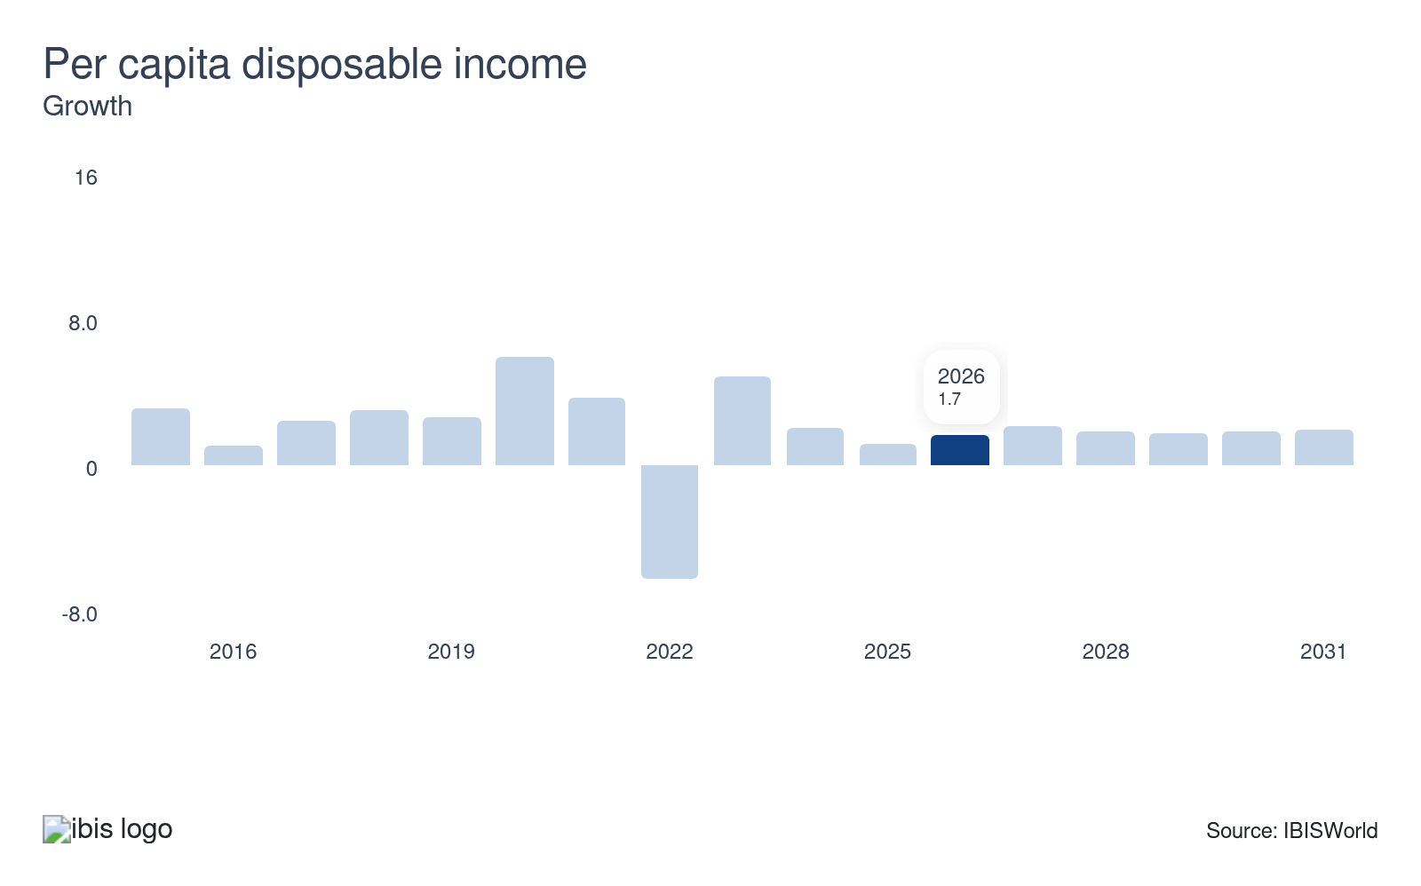
The quality and quantity of a household's grocery consumption are influenced by its disposable income. Low-income households typically consume staple grocery products like milk and bread and favor less expensive brands. Middle—and high-income households expand beyond essential items and select high-quality, private-label brands. As disposable income levels rise, wholesale demand for grocery products will surge. Dips in per capita disposable income pose a potential threat to the industry.
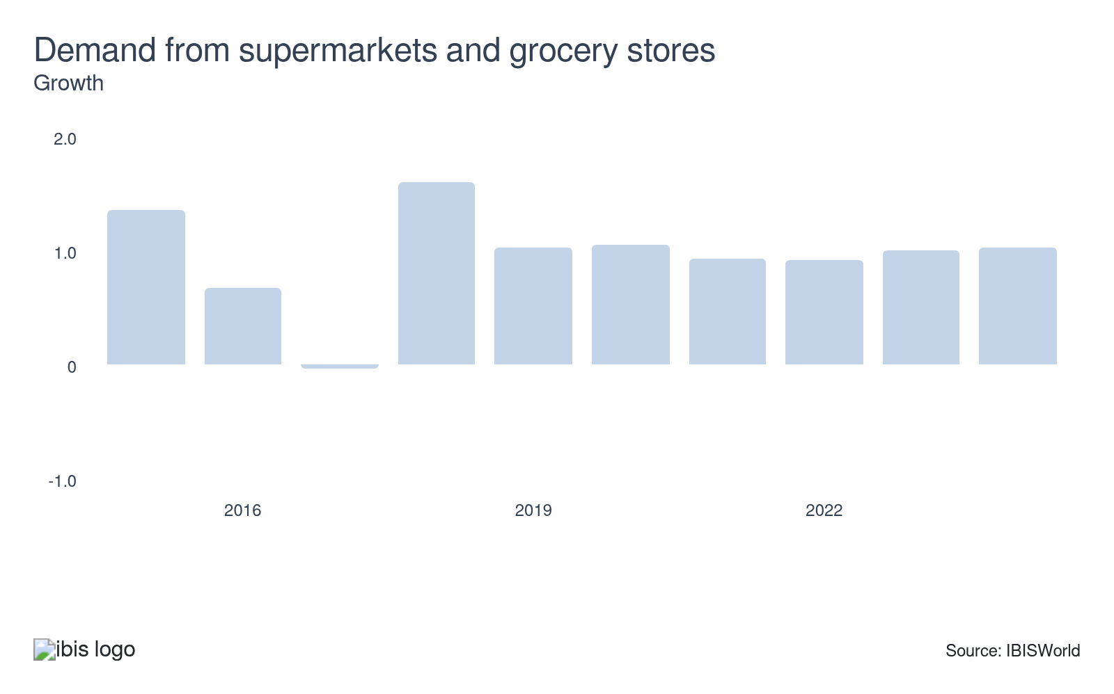
Supermarkets and grocery stores primarily drive the industry. As consumers' demand for groceries surges, the sector's revenue is expected to grow. Given this relationship, higher consumer spending at supermarkets and grocery stores will directly impact revenue growth in wholesaling, specifically soft drinks and baked goods. This boost in the grocery retail sector consequently boosts wholesaling businesses, indicating a promising future for the industry.
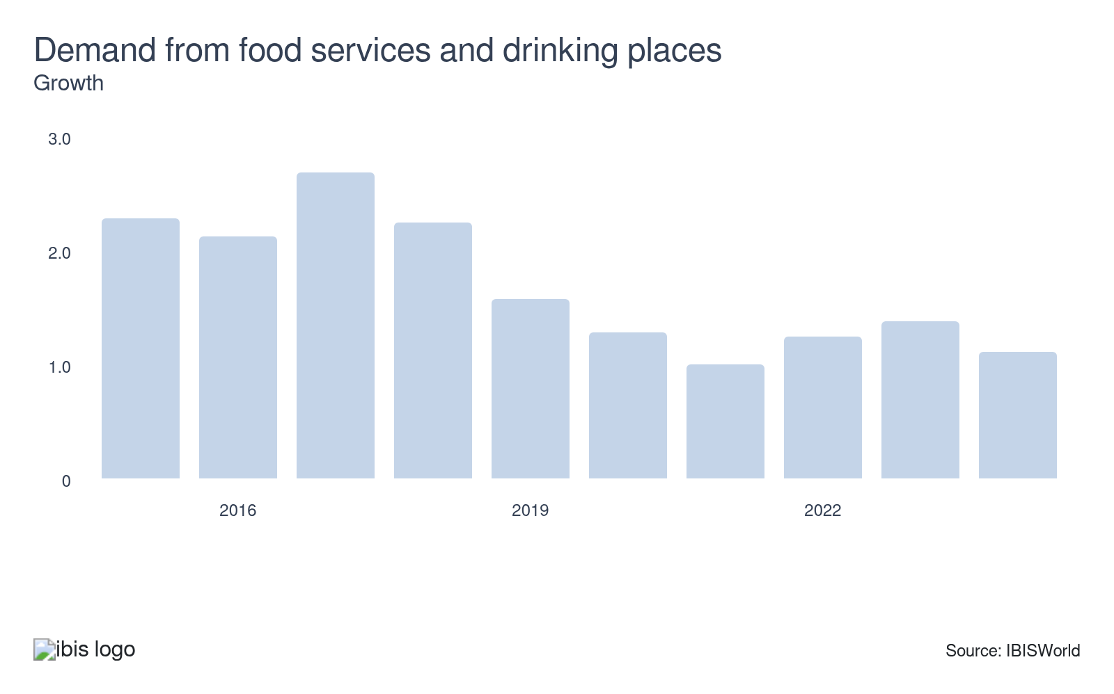
Food service providers, including bars, cafes, coffee shops and restaurants, are a significant market for soft drinks, baked goods and other grocery wholesalers. As a result, an increase in demand from food service establishments will likely lead to a hike in industry revenue. Boosts in demand from food and drinking places represent a potential opportunity for the industry.
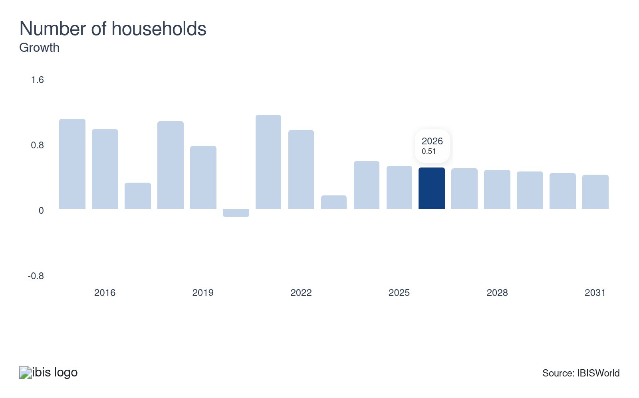
Every household consumes grocery products. As the rate of household formation increases, demand for grocery products grows. Single-person households spend more per capita on grocery products than larger households. Therefore, an acceleration in the overall number of households and the number of single-person households will strengthen demand for grocery products, including industry-relevant products.
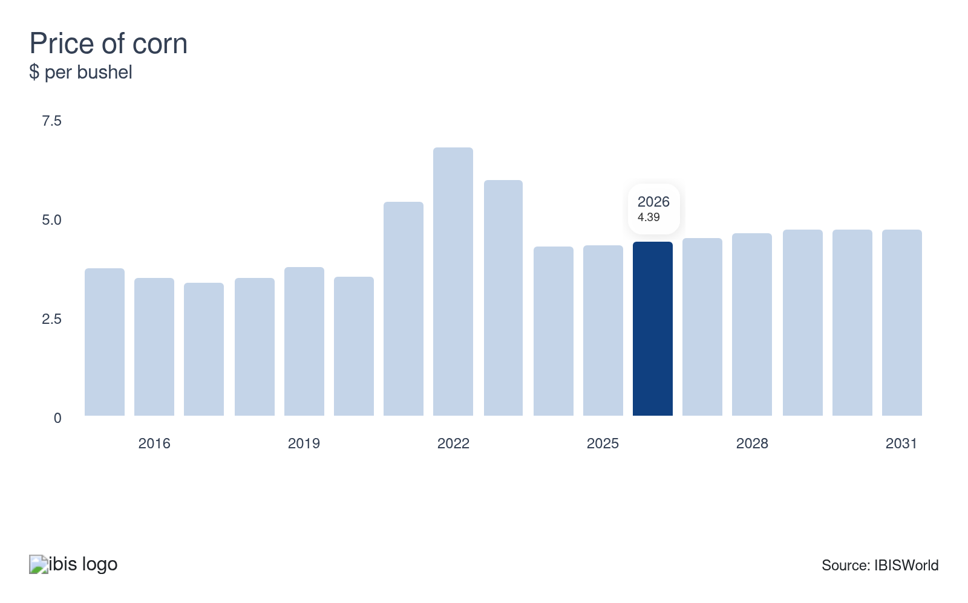
Corn is a major ingredient in many products, including soft drinks and snack foods, that this industry wholesales. An increase in the price of corn will increase the price of products. However, smaller wholesalers with less purchasing power will likely experience declining profits if they can't pass on prices without losing sales.

Regulation & Policy
Moderate | Steady

What regulations impact the industry?

FDA Food Code
The US Food and Drug Administration (FDA) releases its Food Code every four years. Between complete updates, the FDA may provide updates, modifications, or clarify specific provisions. The FDA Food Code is a model for safeguarding public health and ensuring food is unadulterated and honestly presented when offered to consumers. Local, state, tribal and federal regulators use the Food Code to develop food safety rules consistent with FDA policies.

Federal Food, Drug and Cosmetic Act
The FDA Federal Food, Drug and Cosmetic Act oversees the receipt, storage and distribution of produce, ensuring compliance with sanitation standards. This includes fish, seafood, poultry, meat and dairy products, which must adhere to stringent storage requirements to maintain safety and quality. These regulations are enforced through regular inspections by officials to protect public health. The act is crucial in maintaining food safety and preventing contamination throughout the supply chain.

Assistance
Low | Steady

What assistance is available to this industry?

Government incentives
Programs such as former First Lady Michelle Obama's initiative to encourage healthy eating among children in the United States may include incentives for institutional customers to purchase particular industry goods, like more beneficial whole-grain packaged baked goods and low-calorie beverages. Moreover, federal and state food assistance programs, such as the US Department of Agriculture's Women, Infants and Children program, mandate the grocery products available to program beneficiaries. These guidelines can impact retailer purchasing patterns.

Trade associations bolster companies
Industry wholesalers benefit significantly from the support of the National Association of Wholesaler-Distributors (NAW) and the American Wholesale Marketers Association (AWMA). NAW, one of America's leading trade associations, represents the vast $7.4 trillion wholesale distribution industry, providing resources, advocacy and networking opportunities. AWMA, on the other hand, represents over $85.0 billion in convenience product sales in the United States and internationally, offering guidance and support tailored to the unique needs of convenience product distributors. Both organizations play crucial roles in the industry's growth and success.

9. Financial Benchmarks
https://my.ibisworld.com/us/en/industry/42449/financial-benchmarks
Profit Margin  4.0 %  ↑ Higher than sector | Average Wage  $68,335  ↓ Lower than sector | Largest Cost  Purchases  81.2% of Revenue

Key Takeaways
- Input prices have risen, though this hasn't eroded profit. Companies have largely passed down rising costs to downstream markets.
- Wages comprise a smaller share of revenue as selling prices have risen. The innovation aims to reduce dependence on labor.

Cost Structure
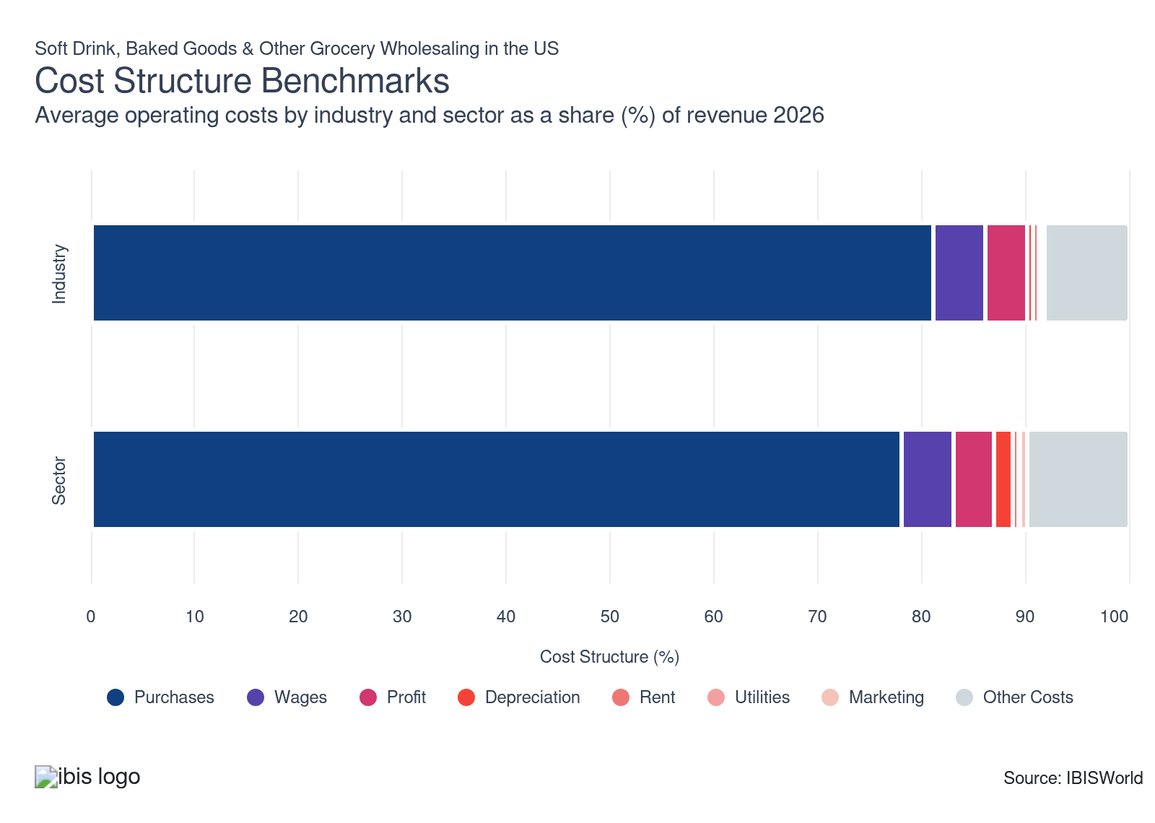
Chart displays current year only in the PDF version of this report. You can view and download chart for all other years associated with this industry on my.ibisworld.com.

What trends impact industry costs?

Wholesalers maintain thin margins while leveraging organic foods and tech-driven efficiencies to sustain profitability
​
- The food wholesale sector still runs on thin, low single-digit margins, so profitability depends on volume, scale economies, and disciplined cost control rather than aggressive pricing power in highly competitive markets.
- Large distributors such as Sysco and US Foods leverage scale to negotiate better supplier pricing, optimize networks, and spread fixed logistics and technology costs across greater volume, supporting stronger operating income despite structurally tight margins.
- According to Organic Trade Association (OTA), US organic product sales reached about 71.6 billion dollars in 2024, growing 5.2% and outpacing overall food-market expansion, making organic and specialty lines attractive mix enhancers for wholesalers seeking higher-value, faster-growing categories.
- Advanced logistics, digital inventory tools, and semi-automation—exemplified by US Foods’ productivity-focused supply chain platforms—reduce waste, labor, and working-capital needs, widening margins when combined with strategic expansion into organic and differentiated product segments.

Wholesalers cut wage expenses with automation amid rising labor costs
- The wholesaling industry still relies heavily on labor for warehousing, transportation, and customer service, yet even as wages and benefits have risen in recent years, labor has remained a relatively stable share of total operating costs.
- Wholesalers in higher-cost or competitive labor markets continue offering attractive pay and comprehensive benefits packages, like those provided by Sysco, to secure and retain workers, while productivity improvements help prevent labor from taking a larger slice of operating expenses.
- Because benefit costs tend to move together with wages, companies emphasize boosting output per employee through better scheduling, training, and digital tools so total compensation can grow without materially changing its proportion of revenue.
- Investments in automation, robotics, and advanced routing or warehouse management systems, similar to those pioneered in large e-commerce fulfillment networks, enable wholesalers to process more volume with similar staffing levels, offsetting higher pay without increasing labor’s overall cost share.

Depreciation costs reflect growing investments in tech and automation
- Depreciation costs increasingly indicate substantial investments in automation, warehouse technology and delivery fleet enhancements. These assets, critical for enhancing efficiency, gradually lose value. This ongoing depreciation impacts operating margins as companies work to meet rising competitive and service demands.
- As competition intensifies and delivery windows narrow, wholesalers automate key processes like pick-and-pack systems and inventory scanning. While these innovations enhance operations, they also increase short-term depreciation expenses, necessitating careful cost-balancing and long-term service improvements.
- The increased use of costly equipment, such as refrigerated trucks and automated storage solutions, contributes to higher fixed asset write-downs. This financial strain can challenge companies with less robust cash flow, particularly during economic downturns or when demand fluctuates unpredictably.
- To manage depreciation, businesses extend asset lifespans through preventive maintenance and adopt scalable technology that permits upgrades without full replacements. Leasing equipment is also gaining traction as a strategy to reduce balance sheet depreciation burdens, enhancing financial flexibility.

Strong supplier ties and inventory management key to managing purchase costs
- Similar to other food and beverage wholesalers, purchase costs are the largest expense for companies in the industry. This category includes goods purchased from food producers and processors that wholesalers then sell to downstream retailers.
- Maintaining strong supplier relationships is crucial for securing favorable terms and a reliable supply chain. These relationships can result in better pricing, priority access during shortages and introductions to new products. Wholesalers gain leverage to negotiate lower prices by purchasing products in large quantities. For example, Sysco's bulk purchasing strategy enables it to obtain volume discounts, effectively managing purchase costs.
- Effective inventory management is vital for wholesalers, as it helps optimize stock levels, reduce holding costs and minimize waste. A prime example is Walmart, whose advanced inventory systems allow for such efficiency. According to a 2022 study by McKinsey, efficient inventory management can cut costs by as much as 20.0%.
- Market conditions, including commodity prices, supply chain disruptions and various economic factors, significantly influence wholesalers' purchase costs. Navigating these fluctuations is essential for maintaining stable purchase costs and ensuring profitability.

Rent is rising due to demand for strategically located distribution hubs
- Wholesalers face soaring rent costs in or near urban centers where proximity to retailers is crucial. The increasing demand for rapid delivery and e-commerce fulfillment has spiked the need for prime warehouse locations near consumer hotspots, intensifying competition and driving up real estate prices.
- Cities like Los Angeles, New Jersey and Chicago have experienced significant increases in industrial real estate costs. Wholesalers in these areas must allocate more operating budgets to maintain proximity to retail clients and logistics partners, making budget management a critical challenge.
- Many companies are opting for smaller regional hubs or shared warehousing models to counteract high urban rent costs. These approaches provide flexibility and reduced fixed costs while maintaining high service levels, allowing wholesalers to navigate financial pressures without sacrificing delivery efficiency.
- Another trend is embedding fulfillment capabilities within existing retail or partner-owned locations. By establishing micro-warehousing within grocery chains or food service operations, wholesalers can reduce rent-related expenses while ensuring quick product access, effectively balancing cost management and service objectives.

Utilities costs are rising as energy-intensive operations expand
- The industry relies heavily on electricity and gas for refrigeration, lighting and continuous operations, particularly in storing soft drinks and perishable goods. This dependency means that fluctuations in energy prices have made utility expenses a volatile and challenging aspect of budget forecasting.
- Recent inflationary pressures and increases in fuel prices have amplified utility costs, consuming a larger portion of overall expenses. These rising costs significantly impact profit margins, particularly for independent wholesalers with less leverage to negotiate favorable bulk energy contracts.
- Companies are installing energy-efficient LED lighting, advanced HVAC systems and automated climate controls to minimize their utility footprint. Also, many are exploring renewable energy options like rooftop solar to achieve long-term energy cost savings and reduce vulnerability to price fluctuations.
- There is a growing trend toward consolidating refrigeration systems and optimizing warehouse layouts to minimize energy waste. Wholesalers committed to sustainability achieve utility cost reductions and become more appealing to retailers focused on green sourcing, aligning operational efficiencies with environmental goals.

Marketing spending is rising as wholesalers compete for shelf space
- In the competitive, low-margin wholesale industry, marketing efforts are intensifying to differentiate offerings and enhance brand recognition for clients' products. Whether through promotional materials or digital campaigns, marketing is becoming a critical strategic element, driving visibility and consumer engagement in a crowded marketplace.
- As private label products rise and shelf space competition intensifies, wholesalers are increasingly tasked with promoting goods to boost sell-through. This shifts some promotional responsibilities from consumer packaged goods (CPG) brands to wholesalers, requiring them to actively engage in marketing initiatives to support their retail partners.
- Some wholesalers leverage data-driven marketing tools and retail analytics to identify top-performing SKUs in specific markets. This targeted approach allows for more effective promotions and improved returns on marketing investments, aligning campaigns with market needs for better efficiency and impact.
- Many businesses are co-investing with manufacturers or opting for digital channels such as social media and email over traditional print advertisements to manage marketing costs. These digital tools offer more measurable outcomes and can be scaled based on performance, providing flexibility and precision in marketing strategies.
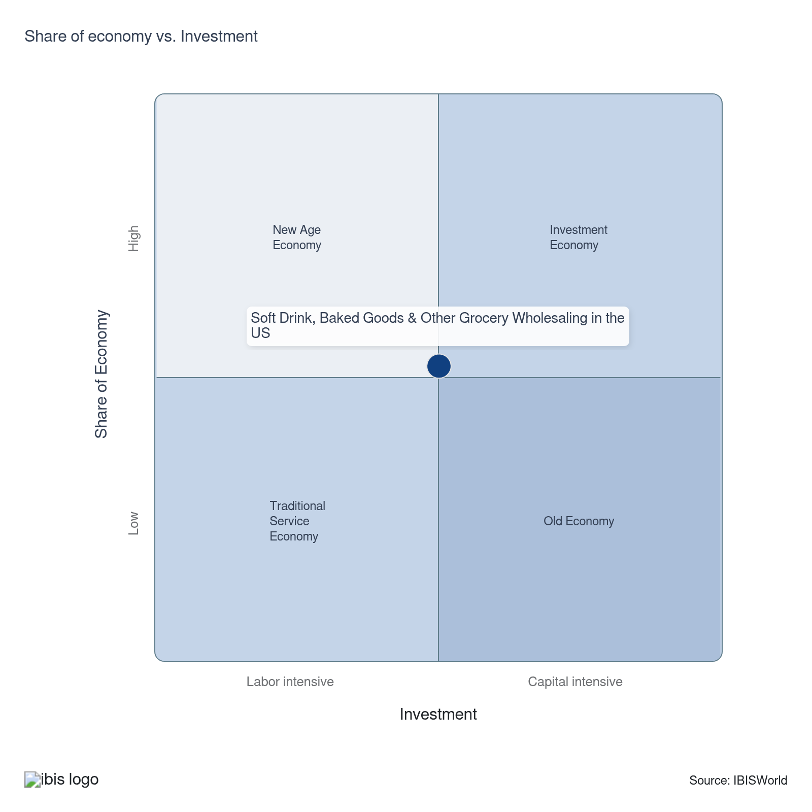

Financial Ratios

Earnings Ratios
Ratio | 2020 | 2021 | 2022 | 2023 | 2024 | 3-Year | 5-Year | 10-Year
EBIT/Revenue | 3.3 | 6.2 | 2.1 | 5.0 | 9.5 | 7.2 | 5.7 | 5.1
EBITDA/Revenue | 5.6 | 8.6 | 4.5 | 7.0 | 14.8 | 10.9 | 8.7 | 7.6
Leverage Ratio | 17.8 | 11.6 | 22.3 | 14.2 | 6.8 | 10.5 | 13.7 | 13.4

Industry Tax Structure
Ratio | 2020 | 2021 | 2022 | 2023 | 2024 | 3-Year | 5-Year | 10-Year
Taxes Paid/Revenue | 0.8 | 0.7 | 0.8 | 0.5 | 0.5 | 0.5 | 0.6 | 0.7

Income Statement
Ratio | 2020 | 2021 | 2022 | 2023 | 2024 | 3-Year | 5-Year | 10-Year
Total Revenue | 100.0 | 100.0 | 100.0 | 100.0 | 100.0 | 100.0 | 100.0 | 100.0
Business receipts | 97.4 | 97.5 | 96.7 | 94.9 | 92.2 | 93.5 | 95.3 | 96.5
Cost of goods | 81.9 | 79.5 | 80.1 | 77.2 | 70.5 | 73.8 | 76.8 | 78.8
Gross Profit | 18.1 | 20.5 | 19.9 | 22.8 | 29.5 | 26.2 | 23.2 | 21.2
Expenses
Salaries and wages | 3.0 | 3.2 | 2.9 | 3.8 | 3.5 | 3.6 | 3.3 | 3.1
Advertising | 0.3 | 0.3 | 0.4 | 0.2 | 0.2 | 0.2 | 0.3 | 0.2
Depreciation | 1.7 | 1.8 | 1.6 | 1.3 | 1.2 | 1.2 | 1.5 | 1.5
Depletion | 0.1 | 0.0 | 0.0 | 0.0 | 0.4 | 0.2 | 0.1 | 0.1
Amortization | 0.5 | 0.6 | 0.8 | 0.7 | 3.7 | 2.2 | 1.5 | 1.0
Rent paid | 0.4 | 0.6 | 0.6 | 0.9 | 0.7 | 0.8 | 0.7 | 0.7
Repairs | 0.6 | 0.6 | 0.6 | 1.1 | 0.6 | 0.8 | 0.7 | 0.6
Bad debts | 0.1 | 0.2 | 2.3 | 0.8 | 0.4 | 0.6 | 0.9 | 0.7
Employee benefit programs | 0.8 | 0.8 | 0.9 | 1.8 | 1.9 | 1.9 | 1.4 | 1.0
Compensation of officers | 0.5 | 0.7 | 0.8 | 0.4 | 0.3 | 0.4 | 0.5 | 0.6
Taxes paid | 0.8 | 0.7 | 0.8 | 0.5 | 0.5 | 0.5 | 0.6 | 0.7
Interest Income | 0.6 | 0.9 | 0.7 | 0.3 | 0.7 | 0.5 | 0.6 | 0.6
Other Income
Royalties | 0.1 | 0.2 | 0.3 | 1.0 | 3.9 | 2.5 | 1.4 | 0.7
Rent Income | 0.4 | 0.4 | 0.7 | 0.9 | 0.4 | 0.7 | 0.6 | 0.6
Net Income | 0.8 | 3.8 | -0.3 | 2.2 | 2.4 | 2.3 | 2.0 | 2.3
Charitable contributions | 0.1 | 0.2 | 0.2 | 0.3 | 0.1 | 0.2 | 0.2 | 0.2
Dividends | 0.1 | 0.2 | 0.2 | 0.4 | 0.2 | 0.3 | 0.3 | 0.2
Interest paid | 1.7 | 1.8 | 1.6 | 2.3 | 6.6 | 4.4 | 3.0 | 2.1
Net gain, noncapital assets | 0.3 | 0.0 | 0.5 | 0.5 | 0.3 | 0.4 | 0.3 | 0.2
Net long-term capital gain less net short-term loss | 0.3 | 0.2 | 0.2 | 0.5 | 1.4 | 1.0 | 0.6 | 0.4
Net loss, noncapital assets | 0.1 | 0.2 | 0.2 | 0.4 | 0.5 | 0.4 | 0.3 | 0.2
Net short-term capital gain less net long-term loss | 0.2 | 0.1 | 0.2 | 1.0 | 0.5 | 0.7 | 0.4 | 0.3
Other deductions | 6.5 | 5.1 | 6.3 | 5.0 | 4.6 | 4.8 | 5.2 | 5.5
Other receipts | 0.5 | 0.5 | 0.5 | 0.5 | 0.5 | 0.5 | 0.5 | 0.5
Pension, profit-sharing, etc., plans | 0.1 | 0.2 | 0.3 | 1.1 | 2.0 | 1.6 | 0.9 | 0.6

Balance Sheet
Ratio | 2020 | 2021 | 2022 | 2023 | 2024 | 3-Year | 5-Year | 10-Year
Assets
Cash and Equivalents | 1.0 | 2.7 | 1.7 | 4.7 | 4.8 | 4.7 | 3.5 | 3.0
Notes and accounts receivable | 8.5 | 8.5 | 8.4 | 11.2 | 15.1 | 13.1 | 10.8 | 7.7
Allowance for bad debts | 0.2 | 0.1 | 0.2 | 1.0 | 1.0 | 1.0 | 0.6 | 0.5
Inventories | 11.1 | 12.8 | 15.2 | 18.0 | 20.9 | 19.4 | 16.7 | 14.5
Other current assets | 3.4 | 3.8 | 5.0 | 5.0 | 5.8 | 5.4 | 4.9 | 3.5
Other investments | 36.8 | 35.3 | 34.1 | 18.3 | 13.5 | 15.9 | 25.3 | 28.5
Property, Plant and Equipment | 13.6 | 14.1 | 18.4 | 23.4 | 26.8 | 25.1 | 20.7 | 19.0
Accumulated depreciation | 5.7 | 6.3 | 11.8 | 13.4 | 15.5 | 14.5 | 11.8 | 7.8
Intangible assets (Amortizable) | 21.0 | 21.0 | 20.6 | 18.3 | 15.6 | 17.0 | 18.9 | 21.3
Accumulated amortization | 3.6 | 3.3 | 3.0 | 3.7 | 3.0 | 3.4 | 3.3 | 2.9
Other assets | 9.4 | 7.5 | 6.3 | 7.3 | 7.1 | 7.2 | 7.1 | 5.3
Total assets | 100.0 | 100.0 | 100.0 | 100.0 | 100.0 | 100.0 | 100.0 | 100.0
Accounts payable | 3.8 | 4.4 | 6.4 | 8.4 | 11.2 | 9.8 | 7.6 | 7.2
Liabilities and Net Worth
Mort, notes, and bonds under 1 yr | 8.2 | 8.1 | 9.2 | 10.7 | 11.7 | 11.2 | 9.9 | 6.2
Other current liabilities | 7.5 | 8.7 | 7.4 | 8.3 | 8.5 | 8.4 | 8.2 | 9.1
Loans from shareholders | 0.2 | 0.2 | 0.2 | 6.5 | 5.9 | 6.2 | 3.2 | 6.5
Mort, notes, bonds, 1 yr or more | 30.1 | 28.2 | 26.6 | 32.8 | 31.8 | 32.3 | 29.8 | 23.8
Other liabilities | 8.7 | 9.0 | 13.6 | 10.3 | 11.1 | 10.7 | 11.0 | 10.0
Total liabilities | 100.0 | 100.0 | 100.0 | 100.0 | 100.0 | 100.0 | 100.0 | 100.0
Capital stock | 4.6 | 4.8 | 4.7 | -0.7 | -2.7 | -1.7 | 1.5 | 3.5
Additional paid-in capital | 28.3 | 26.4 | 21.7 | 21.7 | 13.5 | 17.6 | 20.8 | 30.4
Retained earnings, appropriated | 1.1 | 1.6 | 0.9 | -1.8 | -0.2 | -1.0 | 0.1 | -2.2
Retained earnings-unappropriated | 22.2 | 24.2 | 22.3 | 16.6 | 19.8 | 18.2 | 20.7 | 13.5
Cost of treasury stock | 14.8 | 15.8 | 13.0 | 12.7 | 10.7 | 11.7 | 13.0 | 8.1
Net worth | 41.5 | 41.2 | 36.6 | 23.2 | 19.8 | 21.5 | 30.2 | 37.1
Accumulated depletion | 0.0 | 0.0 | 0.1 | 0.1 | 0.1 | 0.1 | 0.1 | 0.0
Depletable assets | 1.0 | 0.7 | 1.7 | 0.8 | 0.4 | 0.6 | 0.9 | 0.5
Government Obligations | 0.6 | 0.6 | 0.6 | 0.7 | 0.6 | 0.7 | 0.6 | 1.0
Land | 1.1 | 0.9 | 0.9 | 3.4 | 2.6 | 3.0 | 1.9 | 2.1
Loans to shareholders | 0.1 | 0.1 | 0.1 | 1.2 | 1.3 | 1.3 | 0.7 | 2.5
Mortgage and real estate loans | 0.0 | 0.5 | 0.0 | 5.1 | 4.4 | 4.8 | 2.5 | 1.5
Tax Exempt Securities | 1.9 | 1.3 | 2.0 | 0.9 | 0.8 | 0.8 | 1.2 | 0.8

Liquidity Ratios
Ratio | 2020 | 2021 | 2022 | 2023 | 2024 | 3-Year | 5-Year | 10-Year
Current Ratio | 1.4 | 1.4 | 1.4 | 1.5 | 1.6 | 1.5 | 1.5 | 1.4
Quick Ratio | 0.8 | 0.8 | 0.8 | 0.9 | 0.9 | 0.9 | 0.8 | 0.7
Sales/Receivables | 11.8 | 11.8 | 11.9 | 8.9 | 6.6 | 7.8 | 9.8 | 26.4
Days' Receivables | 30.9 | 31.0 | 30.6 | 40.8 | 55.0 | 47.9 | 39.4 | 28.1
Days' Inventory | 49.5 | 58.7 | 69.5 | 84.9 | 108.3 | 96.6 | 80.3 | 63.0
Inventory Turnover | 7.4 | 6.2 | 5.3 | 4.3 | 3.4 | 3.8 | 4.8 | 6.4
Payables Turnover | 21.6 | 18.0 | 12.6 | 9.2 | 6.3 | 7.8 | 11.5 | 13.4
Days' Payables | 16.9 | 20.3 | 29.0 | 39.6 | 58.0 | 48.8 | 36.7 | 31.1
Sales/Working Capital | 13.3 | 11.7 | 9.5 | 6.7 | 5.2 | 6.0 | 8.3 | 13.5

Coverage Ratios
Ratio | 2020 | 2021 | 2022 | 2023 | 2024 | 3-Year | 5-Year | 10-Year
Interest Coverage | 1.9 | 3.6 | 1.3 | 2.2 | 1.4 | 1.8 | 2.1 | 2.9
Debt Service Coverage Ratio | 0.5 | 1.1 | 0.6 | 0.9 | 1.9 | 1.4 | 1.1 | 1.4

Leverage Ratios
Ratio | 2020 | 2021 | 2022 | 2023 | 2024 | 3-Year | 5-Year | 10-Year
Fixed Assets/Net Worth | 1.1 | 1.1 | 1.5 | 2.7 | 3.2 | 3.0 | 2.2 | 1.6
Debt/Net Worth | 2.4 | 2.4 | 2.7 | 4.3 | 5.0 | 4.7 | 3.6 | 2.9
Tangible Net Worth | 41.5 | 41.2 | 36.6 | 23.2 | 19.8 | 21.5 | 30.2 | 37.1

Operating Ratios
Ratio | 2020 | 2021 | 2022 | 2023 | 2024 | 3-Year | 5-Year | 10-Year
Return on Net Worth, % | 7.9 | 15.2 | 5.7 | 21.4 | 47.8 | 34.6 | 22.5 | 17.1
Return on Assets, % | 3.3 | 6.2 | 2.1 | 5.0 | 9.5 | 7.2 | 5.7 | 5.1
Sales/Total Assets | 1.0 | 1.0 | 1.0 | 1.0 | 1.0 | 1.0 | 1.0 | 1.0
EBITDA/Revenue | 5.6 | 8.6 | 4.5 | 7.0 | 14.8 | 10.9 | 8.7 | 7.6
EBIT/Revenue | 3.3 | 6.2 | 2.1 | 5.0 | 9.5 | 7.2 | 5.7 | 5.1

Cash Flow & Debt Service Ratios (% of sales)
Ratio | 2020 | 2021 | 2022 | 2023 | 2024 | 3-Year | 5-Year | 10-Year
Cash from Trading | 22.7 | 18.2 | 15.4 | 20.9 | 27.6 | 24.3 | 20.5 | 21.3
Cash after Operations | 13.0 | 13.8 | 7.6 | 15.3 | 21.8 | 18.5 | 14.6 | 14.6
Net Cash after Operations | 17.7 | 12.7 | 9.0 | 16.0 | 27.0 | 21.5 | 16.2 | 16.4
Debt Service P&I Coverage | 1.7 | 1.2 | 0.8 | 1.2 | 1.4 | 1.3 | 1.1 | 3.0
Interest Coverage (Operating Cash) | 10.3 | 7.3 | 5.7 | 7.1 | 4.1 | 5.6 | 6.0 | 9.6

Valuation Multiples

Valuation Multiples
Ratio | 2020 | 2021 | 2022 | 2023 | 2024 | 3-Year | 5-Year | 10-Year
EV/Revenue | 0.7 | 0.8 | 0.7 | 0.7 | 0.7 | 0.7 | 0.7 | 0.7
EV/EBITDA | 3.7 | 6.1 | 7.9 | 4.9 | 3.5 | 5.4 | 5.2 | 6.2
EV/EBIT | 5.0 | 9.1 | 17.1 | 6.9 | 5.5 | 9.8 | 8.7 | 12.2

Key Ratios
Year | Revenue per Employee  ($) | Revenue per Enterprise  ($ Million) | Employees per Estab.  (Units) | Employees per Enterprise  (Units) | Average Wage  ($) | Wages/ Revenue  (%) | Estab. per Enterprise  (Units) | IVA/ Revenue  (%)
2003 | 1,164,271 | 16.5 | 12.2 | 14.1 | 64,039 | 5.5 | 1.2 | 10.2
2004 | 1,163,108 | 16.9 | 12.4 | 14.6 | 65,871 | 5.7 | 1.2 | 9.8
2005 | 1,196,262 | 17.2 | 12.3 | 14.4 | 66,766 | 5.6 | 1.2 | 8.9
2006 | 1,217,142 | 17.6 | 12.4 | 14.5 | 65,411 | 5.4 | 1.2 | 9.4
2007 | 1,303,780 | 19.0 | 12.4 | 14.5 | 64,753 | 5.0 | 1.2 | 8.9
2008 | 1,230,673 | 19.3 | 13.3 | 15.7 | 64,927 | 5.3 | 1.2 | 8.7
2009 | 1,271,241 | 19.1 | 12.7 | 15.1 | 67,681 | 5.3 | 1.2 | 9.6
2010 | 1,303,677 | 19.6 | 12.7 | 15.1 | 69,508 | 5.3 | 1.2 | 9.5
2011 | 1,366,848 | 20.5 | 12.4 | 15.0 | 68,110 | 5.0 | 1.2 | 9.2
2012 | 1,430,719 | 18.9 | 11.1 | 13.2 | 68,976 | 4.8 | 1.2 | 9.0
2013 | 1,401,030 | 19.5 | 11.9 | 13.9 | 67,890 | 4.8 | 1.2 | 8.9
2014 | 1,347,573 | 19.7 | 12.5 | 14.6 | 65,521 | 4.9 | 1.2 | 8.5
2015 | 1,295,379 | 20.1 | 13.1 | 15.5 | 67,166 | 5.2 | 1.2 | 9.4
2016 | 1,291,883 | 19.7 | 12.9 | 15.3 | 67,748 | 5.2 | 1.2 | 10.1
2017 | 1,222,582 | 17.8 | 12.2 | 14.5 | 68,237 | 5.6 | 1.2 | 9.7
2018 | 1,176,371 | 18.4 | 13.2 | 15.7 | 67,533 | 5.7 | 1.2 | 9.9
2019 | 1,220,825 | 18.5 | 12.7 | 15.1 | 67,538 | 5.5 | 1.2 | 9.8
2020 | 1,357,315 | 19.4 | 12.0 | 14.3 | 69,553 | 5.1 | 1.2 | 9.7
2021 | 1,490,189 | 20.0 | 11.4 | 13.4 | 71,979 | 4.8 | 1.2 | 9.6
2022 | 1,442,558 | 21.1 | 12.4 | 14.6 | 69,044 | 4.8 | 1.2 | 9.6
2023 | 1,377,908 | 20.8 | 12.9 | 15.1 | 68,532 | 5.0 | 1.2 | 9.7
2024 | 1,361,986 | 20.4 | 12.7 | 15.0 | 68,376 | 5.0 | 1.2 | 9.7
2025 | 1,355,011 | 20.2 | 12.7 | 14.9 | 68,306 | 5.0 | 1.2 | 9.7
2026 | 1,358,124 | 20.3 | 12.7 | 14.9 | 68,335 | 5.0 | 1.2 | 9.6
2027 | 1,361,201 | 20.4 | 12.8 | 15.0 | 68,367 | 5.0 | 1.2 | 9.7
2028 | 1,358,780 | 20.4 | 12.8 | 15.0 | 68,342 | 5.0 | 1.2 | 9.7
2029 | 1,356,250 | 20.4 | 12.9 | 15.1 | 68,317 | 5.0 | 1.2 | 9.7
2030 | 1,357,716 | 20.5 | 12.9 | 15.1 | 68,331 | 5.0 | 1.2 | 9.7
2031 | 1,360,838 | 20.6 | 12.9 | 15.2 | 68,363 | 5.0 | 1.2 | 9.7
2032 | 1,344,787 | 20.2 | 12.8 | 15.0 | 68,202 | 5.1 | 1.2 | 9.7
*Figures are inflation adjusted to 2026
*Figures are inflation adjusted to 2026

10. Key Statistics
https://my.ibisworld.com/us/en/industry/42449/key-statistics

Industry Data

Values
Year | Revenue  ($ Million) | IVA  ($ Million) | Estab.  (Units) | Enterprises  (Units) | Employment  (Units) | Wages  ($ Million)
2003 | 315,144.9 | 32,145.9 | 22,108 | 19,134 | 270,680 | 17,334.1
2004 | 319,665.2 | 31,210.0 | 22,084 | 18,864 | 274,837 | 18,103.8
2005 | 329,621.6 | 29,274.2 | 22,416 | 19,135 | 275,543 | 18,396.8
2006 | 339,983.1 | 31,870.4 | 22,616 | 19,275 | 279,329 | 18,271.1
2007 | 352,224.0 | 31,230.2 | 21,761 | 18,582 | 270,156 | 17,493.4
2008 | 372,390.4 | 32,307.7 | 22,781 | 19,311 | 302,591 | 19,646.4
2009 | 367,716.6 | 35,389.0 | 22,812 | 19,219 | 289,258 | 19,577.2
2010 | 379,651.5 | 36,187.1 | 22,985 | 19,344 | 291,216 | 20,241.8
2011 | 397,778.6 | 36,527.9 | 23,383 | 19,401 | 291,019 | 19,821.2
2012 | 402,781.7 | 36,335.2 | 25,265 | 21,353 | 281,524 | 19,418.5
2013 | 413,570.1 | 36,996.8 | 24,836 | 21,233 | 295,190 | 20,040.6
2014 | 415,844.8 | 35,189.3 | 24,616 | 21,140 | 308,588 | 20,218.9
2015 | 415,394.4 | 38,984.9 | 24,405 | 20,704 | 320,674 | 21,538.4
2016 | 409,138.1 | 41,503.6 | 24,503 | 20,726 | 316,699 | 21,455.8
2017 | 401,389.5 | 38,860.0 | 26,883 | 22,577 | 328,313 | 22,403.1
2018 | 410,644.0 | 40,821.1 | 26,517 | 22,258 | 349,077 | 23,574.1
2019 | 420,404.7 | 41,101.4 | 27,078 | 22,760 | 344,361 | 23,257.4
2020 | 423,195.8 | 40,857.5 | 25,916 | 21,847 | 311,789 | 21,685.7
2021 | 456,406.1 | 43,843.1 | 26,834 | 22,810 | 306,274 | 22,045.4
2022 | 492,835.4 | 47,421.5 | 27,504 | 23,364 | 341,640 | 23,588.3
2023 | 489,314.3 | 47,242.3 | 27,591 | 23,473 | 355,114 | 24,336.8
2024 | 480,650.4 | 46,425.9 | 27,692 | 23,594 | 352,904 | 24,130.0
2025 | 477,478.8 | 46,110.9 | 27,694 | 23,611 | 352,380 | 24,069.6
2026 | 483,050.7 | 46,605.5 | 27,932 | 23,814 | 355,675 | 24,305.2
2027 | 489,268.8 | 47,216.8 | 28,154 | 24,001 | 359,439 | 24,573.6
2028 | 495,240.0 | 47,812.0 | 28,494 | 24,295 | 364,474 | 24,908.9
2029 | 501,927.8 | 48,475.8 | 28,796 | 24,548 | 370,085 | 25,283.0
2030 | 508,513.5 | 49,105.8 | 29,061 | 24,769 | 374,536 | 25,592.6
2031 | 516,071.9 | 49,818.5 | 29,364 | 25,020 | 379,231 | 25,925.3
2032 | 502,300.7 | 48,539.7 | 29,198 | 24,915 | 373,517 | 25,474.5

*Figures are inflation adjusted to 2026

Annual Change
Year | Revenue  % | IVA  % | Estab.  % | Enterprises  % | Employment  % | Wages  %
2003 | N/A | N/A | N/A | N/A | N/A | N/A
2004 | 1.4 | -2.9 | -0.1 | -1.4 | 1.5 | 4.4
2005 | 3.1 | -6.2 | 1.5 | 1.4 | 0.3 | 1.6
2006 | 3.1 | 8.9 | 0.9 | 0.7 | 1.4 | -0.7
2007 | 3.6 | -2.0 | -3.8 | -3.6 | -3.3 | -4.3
2008 | 5.7 | 3.5 | 4.7 | 3.9 | 12.0 | 12.3
2009 | -1.3 | 9.5 | 0.1 | -0.5 | -4.4 | -0.4
2010 | 3.2 | 2.3 | 0.8 | 0.7 | 0.7 | 3.4
2011 | 4.8 | 0.9 | 1.7 | 0.3 | -0.1 | -2.1
2012 | 1.3 | -0.5 | 8.0 | 10.1 | -3.3 | -2.0
2013 | 2.7 | 1.8 | -1.7 | -0.6 | 4.9 | 3.2
2014 | 0.6 | -4.9 | -0.9 | -0.4 | 4.5 | 0.9
2015 | -0.1 | 10.8 | -0.9 | -2.1 | 3.9 | 6.5
2016 | -1.5 | 6.5 | 0.4 | 0.1 | -1.2 | -0.4
2017 | -1.9 | -6.4 | 9.7 | 8.9 | 3.7 | 4.4
2018 | 2.3 | 5.0 | -1.4 | -1.4 | 6.3 | 5.2
2019 | 2.4 | 0.7 | 2.1 | 2.3 | -1.4 | -1.3
2020 | 0.7 | -0.6 | -4.3 | -4.0 | -9.5 | -6.8
2021 | 7.8 | 7.3 | 3.5 | 4.4 | -1.8 | 1.7
2022 | 8.0 | 8.2 | 2.5 | 2.4 | 11.5 | 7.0
2023 | -0.7 | -0.4 | 0.3 | 0.5 | 3.9 | 3.2
2024 | -1.8 | -1.7 | 0.4 | 0.5 | -0.6 | -0.8
2025 | -0.7 | -0.7 | 0.0 | 0.1 | -0.1 | -0.3
2026 | 1.2 | 1.1 | 0.9 | 0.9 | 0.9 | 1.0
2027 | 1.3 | 1.3 | 0.8 | 0.8 | 1.1 | 1.1
2028 | 1.2 | 1.3 | 1.2 | 1.2 | 1.4 | 1.4
2029 | 1.4 | 1.4 | 1.1 | 1.0 | 1.5 | 1.5
2030 | 1.3 | 1.3 | 0.9 | 0.9 | 1.2 | 1.2
2031 | 1.5 | 1.5 | 1.0 | 1.0 | 1.3 | 1.3
2032 | -2.7 | -2.6 | -0.6 | -0.4 | -1.5 | -1.7

*Figures are inflation adjusted to 2026

DISCLAIMER
This product has been supplied by IBISWorld Inc. (‘IBISWorld’) solely for use by its authorized licenses strictly in accordance with their license agreements with IBISWorld. IBISWorld makes no representation to any other person with regard to the completeness or accuracy of the data or information contained herein, and it accepts no responsibility and disclaims all liability (save for liability which cannot be lawfully disclaimed) for loss or damage whatsoever suffered or incurred by any other person resulting from the use of, or reliance upon, the data or information contained herein. Copyright in this publication is owned by IBISWorld Inc. The publication is sold on the basis that the purchaser agrees not to copy the material contained within it for other than the purchasers own purposes. In the event that the purchaser uses or quotes from the material in this publication – in papers, reports, or opinions prepared for any other person – it is agreed that it will be sourced to: IBISWorld Inc.

